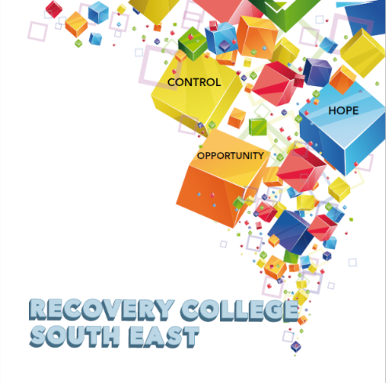

Greenshill
Kilkenny
056 7703666
086 1746330

recoverycollegesoutheast@gmail.com

Workshop Descriptors
Workshop Title | Description
Changing Habits Programme (6 week workshop)  To get the full benefit from this series of workshops, it is recommended that you attend all sessions. | Habits can be healthy and self-empowering. However, some habits can be self-defeating, demotivating and limiting, preventing us from realizing our full potential. This 6 week course is designed to explore “habits” and to find ways to let go of habits that no longer serve us, and to create new, more adaptive habits that will serve our best selves. Successful change follows a pattern, a pattern you can use to make the changes that matter to you. Each week is of 2 hours duration with a tea/coffee break, and each week builds on the previous week, so it is important to attend all of the 6 weeks if you can.
Compassionate Mind  (4 Week Workshop)  To get the full benefit from this series of workshops, it is recommended that you attend all sessions. | Compassion focused mindfulness practice specifically looks at cultivating and fostering a kinder, more soothing approach to deal with difficult emotions and self-criticism.  The aim of this workshop is:  - To recognize how critical self-talk lowers mood and sets up vicious negative cycles of feeling awful about ourselves.  - To build compassion for ourselves to help counteract these vicious cycles. With a compassionate focus we can learn to think in a way that helps us to be more accepting of ourselves
Creative Writing | Finding it hard to fill in your day? Looking for an activity or new interest? Why not join our online creative writing group? Its fun, it’s entertaining and it is also a great way to meet new friends.  This group is open to anyone, regardless of whether you are an experienced writer, a beginner or even just curious abbot creative writing. This is a great way to express yourself and what may be going on for you in your world.  So, come along, join the group and give it a go. Looking forward to meeting you.
Getting a Good Night’s Sleep | Do you have difficulty getting off to sleep at night? Wake up early in the morning? Spend the night tossing and turning? Getting a good night’s sleep and developing a good sleep routine is important for your wellbeing and recovery.  This aim of this workshop is to:  - Explore the different stages of sleep  - Discover the common causes of sleep problems  - Identify techniques to develop better sleeping habits.
Good Communication Skills  - How do we communicate  - Communications and our emotions  - Learning good communication skills  To get the full benefit from this series of workshops, it is recommended that you attend all sessions. | Good communication is key to any successful relationship, be it with your friends, family or in more formal or professional situations  The word conversation generally brings to mind talking. However, have you ever seen two people talking to each other at the same time, you will know that listening is just as important. In fact listening is half of a successful conversation. You take turns to talk and everybody feels heard.  The aim of this 3 part workshop is:  - To explore how we communicate  - To gain an understanding of the link between how you feel and how you communicate.  - To develop a range of communication skills that can help in areas such as relationships, work and social situations.
Growing Towards Health and Wellness – In house  (10 week workshop) | Calling all “greenfingers” and those that have an interest but not necessarily the knowledge skills or experience in gardening. We would like your help in further developing our garden into an open space that reflects wellness and recovery, where people can sit, relax and enjoy.  The aim of this workshop is  - To offer people an opportunity to explore the link between gardening, nature, wellness and wellbeing, while having the practical elements of designing, planting, sowing and digging.  - To experience the creation of a physical thing from your own work, that you can then use to nourish yourself, is a great boost to self-esteem that can’t be underestimated.
Loneliness and Isolation  (4 morning workshops)  To get the full benefit from this series of workshops, it is recommended that you attend all sessions. | Everybody can be affected by loneliness and isolation, and research shows that it can especially cause difficulties for recovery in mental and physical health.  The aim of this workshop is to:  - Explore how loneliness and isolation impacts on all aspects of life  - Share ideas on how loneliness and isolation can be positively addressed  - Identify practical ways of making connections to others.  - Explore what resources and services are available locally
Mindfulness  (4 Week Workshop)  To get the full benefit from this series of workshops, it is recommended that you attend all sessions. | Mindfulness is about focusing on how things actually are in a given moment, not on what might have happened in the past, or how we might want things to be in the future.  With mindfulness we can learn to think in a way that helps us to be at peace with our thoughts and emotions.  The aim of this workshop is:  - To introduce Mindfulness and explore what it is.  - To demonstrate short mindful practical meditations that can be used in ever day life for self-care and personal wellness.
Personal Development Programme (8 weeks)  To get the full benefit from this series of workshops, it is recommended that you attend all sessions. | - Introduction to Personal Development  The aim of this session is to explore the components of personal development and how it can benefit us in achieving our goals in life.  - Self-Awareness  The aim of this session is to develop the participants’ understanding of self-awareness and its benefits for everyday living.  - Developing Positive Thinking  The aim of this session is to help participants identify patterns of negative thinking and to acquire skills to help develop positive thinking.  - Building our Self –Confidence and Self Belief  The aim of this session is to define and discuss self-confidence and belief in self, to empower participants to develop practical ways for building their own self-belief.  - Assertiveness  The aim of this session is to enhance participants’ understanding of what assertiveness is and to practice assertiveness skills.  - Effective communication  The aim of this session is to explore the concept of communication and the role it plays in your life and to develop effective communication skills through exploring a range of tips and tools.  - Maintaining Motivation  The aim of this session is to help participants understand motivation and identify effective strategies to increase and maintain a high level of motivation.  - Self-care and Wellbeing  The aim of this session is to enable participants to understand what wellbeing is and to provide participants with practical self- care tips and tools to be able to manage and reduce stress in their day to day working and personal life.  Reflective Session  Delivered 4-6 weeks after completion of the programme, to check in with the Group and revisit areas of learning.
Personal Narrative  (3 week workshop)  To get the full benefit from this series of workshops, it is recommended that you attend all sessions. | Everyone of us has a story to tell. Stories entertain us, inform us and can help us to make sense of our world and out life experience. The use and benefit of personal narrative in mental health recovery is well established and documented (Egglestone, 2019).  This 3-part workshop will introduce the topic of personal narrative and discuss some of the main aspects of its sage use in promoting and advancing recovery.  The aim of this workshop is to:  - Explore the positive role of personal narrative in mental health recovery  - Look at some of the potential risks associates with personal narrative  - Discuss practical ways of developing and delivering personal narrative
Practical Facilitation Skills  To get the full benefit from this series of workshops, it is recommended that you attend all sessions. | Delivering an effective presentation and having basic facilitation skills, whether for a recovery education workshop or for other training sessions, to talk at a conference or even get through a job interview, is becoming increasingly important.  The aim of this 4 part workshop is to  - Gain a good understanding of the roles and responsibilities of a facilitator  - Explore co-facilitation in relation to recovery education.  - Explore different facilitation styles, the power of body language, helpful attitudes, values and interpersonal skills.  - Gain practical experience in developing and delivering a short 10 minute presentation in a safe and supportive environment.
Recovery Principles and Practice | Recovery Principles and Practice aims to bring an increased awareness to all staff in the Mental Health Services of the benefits of a recovery approach in practice. The training is built on incorporating the unique expertise that core stakeholders, service users, family members and service providers bring to the recovery process.
Support group for people who live with Anxiety | This peer support group will give you an opportunity to share openly and safely your personal experience of anxiety, what worked well for you, the day-to-day challenges of living with anxiety, a chance to share your knowledge with and also learn coping tips and tools from others who have experience of anxiety.  This group is open to everyone and will meet the last Monday of every Month from 10am-11am.
Understanding and Managing Anxiety ( Four week workshop )  To get the full benefit from this series of workshops, it is recommended that you attend all sessions. | Everyone experiences periods of anxiety at some stage in their lives. We can feel tense, uncertain, fearful or nervous. Anxiety is a word used to describe these moments of discomfort. Anxiety can change from something everyone experiences in mild forms, to something which is persistent, excessive or over-whelming. It can begin to interfere with many aspects of your life – from confidence, to physical wellbeing and engagement in basic or complex activities of living.  The aim of this 4-part workshop is:  - to explore the facts and origins of anxiety,  - explore the causes and symptoms associated with anxiety  - look at and how anxiety affects people in different ways –  - Explore practical and effective ways of managing and living with anxiety.
Understanding and Living well with Bi Polar (2 week workshop)  To get the full benefit from this series of workshops, it is recommended that you attend all sessions. | Living with Bipolar can be a turbulent experience and for some can cause them to lose sight of who they are and what is important to them. This 2-part workshop will explore bipolar and help you to better understand what it is and how you can best live with it.  The aim of this workshop is:  - To explore what bipolar means to you and how it affects your life  - To discuss the causes of bipolar and the role of stress and underlying vulnerabilities  - To explore effective strategies to help manage and live well with bipolar
Understanding and Managing Addictions  (4 week workshop)  To get the full benefit from this series of workshops, it is recommended that you attend all sessions. | People often experience problems with both mental health and addictions, and finding the right help and support can be difficult.  The aim of this series of 4 part workshop is to:  - Explore the many different aspects of this complex social issue.  - Examine the relationship between mental health challenges and addictions  - Identify commonly misused substances and the effects they can have on mental health, physical health and the person’s social circumstances  - Explore people’s reasons for the repeated misuse of substances  - Discuss the role of the family in the recovery process  - Support you in making informed choices on the recovery journey  - Identify the role of community supports in the recovery process
Understanding and Living with Hearing Voices | The experience of hearing voices can differ from person to person. Our uniqueness as individuals is often reflected in the voices people experience. These voices can have distinct content, identities, meaning and impact on the person experiencing them.  The aim of this workshop is:  - to gain a better understanding of the common nature of voice hearing,  - to explore the different individual experiences within the group  - to discuss and share ideas for managing and living well with hearing voices
Understanding and living with Paranoia | Many people experience paranoid thoughts at some point in their lives and people have different experiences of paranoia. The symptoms vary in severity and may interfere with all areas of life.  The aim of this workshop is to:  - Explore paranoia and gain a better understanding of what paranoia might mean for you, for someone you care about, or work with and how it may affect your life.  - Discuss some of the strategies for managing the experience of paranoia when it is distressing.
Understanding and Living with Psychosis | Psychosis can be experienced as having a different sense of reality to other people or hearing voices. While psychosis is surprisingly common, it can be a very unsettling and frightening experience for the person experiencing it as well as the people who care about them. This workshop is for anyone who wants to better understand psychosis and learn effective ways of living well it.  The aim of this workshop is:  - To help you to understand psychosis through exploring existing knowledge and different perspectives around the topic  - To provide coping strategies for living with psychosis and for promoting recovery
Understanding and Managing Depression  (4 week workshop)  To get the full benefit from this series of workshops, it is recommended that you attend all sessions. | Depression can be experienced differently from person to person. This 4-part workshop helps you to explore depression and understand what it means to you and how you can manage it effectively.  The aim of this workshop is:  - To explore what depression is and the factors that may lead to depression  - To provide practical and effective ways to help promote recovery from depression
Working Together- Co-Production | Co-Production has emerged and been identified as a concept that helps in the delivery of recovery orientated services within the mental health arena (BOBAIRD 2007; Dunston et al. 2009)  The process of co-production can occur in various different ways and many areas around the country have been successfully working in co-production.  This workshop is practical in nature and will involve group exercises that are designed to increase your skills and enhance your competence in all aspects of Co-Production.  The aim of this 4 part series of workshops is to  - Explore the co-production process and how it works within mental health services.  - Explore Co-Production and Recovery Education  - Understand and learn more about the role of Personal Narratives in Co-Production
WRAP – Level 1  (2 day workshop)  To get the full benefit from this series of workshops, it is recommended that you attend all sessions. | WRAP is for everybody. WRAP helps you to get to know yourself. WRAP is your personal plan which you have put in place in the good times to remind you and guide you through the bad times. WRAP helps to achieve and maintain  wellness and gain more control over our lives and the way we feel. It is developed to help us identify what works and what doesn’t work and how we can get better at staying well.

Greenshill
Kilkenny
056 7703666
086 1746330

recoverycollegesoutheast@gmail.com

Recovery College South East Enrolment Form
Course title | Commencement date

PLEASE COMPLETE USING BLOCK CAPITAL LETTERS
Surname:

First name(s)

Address:

Telephone: | Mobile | Home/Work
Email:
Contact Details in Case of Emergency: | Name | Number
Where did you hear about the Recovery College
All our workshops are based around discussion and group work. Pen and paper would be helpful to have to hand for participants.
Please note that we ask for your address and also an emergency contact number of a person who will come to your aid in times of an emergency during a virtual ZOOM workshop. For example, if a student collapses during a ZOOM workshop and is on their own in the house, we will be unable to support you without your address and contact number of a person who can call to your house. This has never happened but it is important that we are prepared if it does, and the facilitators can support you.

All our Workshops are free of charge.
Are you happy for us to contact you periodically by email, post or text about different events, workshops, surveys in relation to the Recovery College South East ? (Please tick this box if yes.)

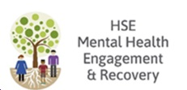
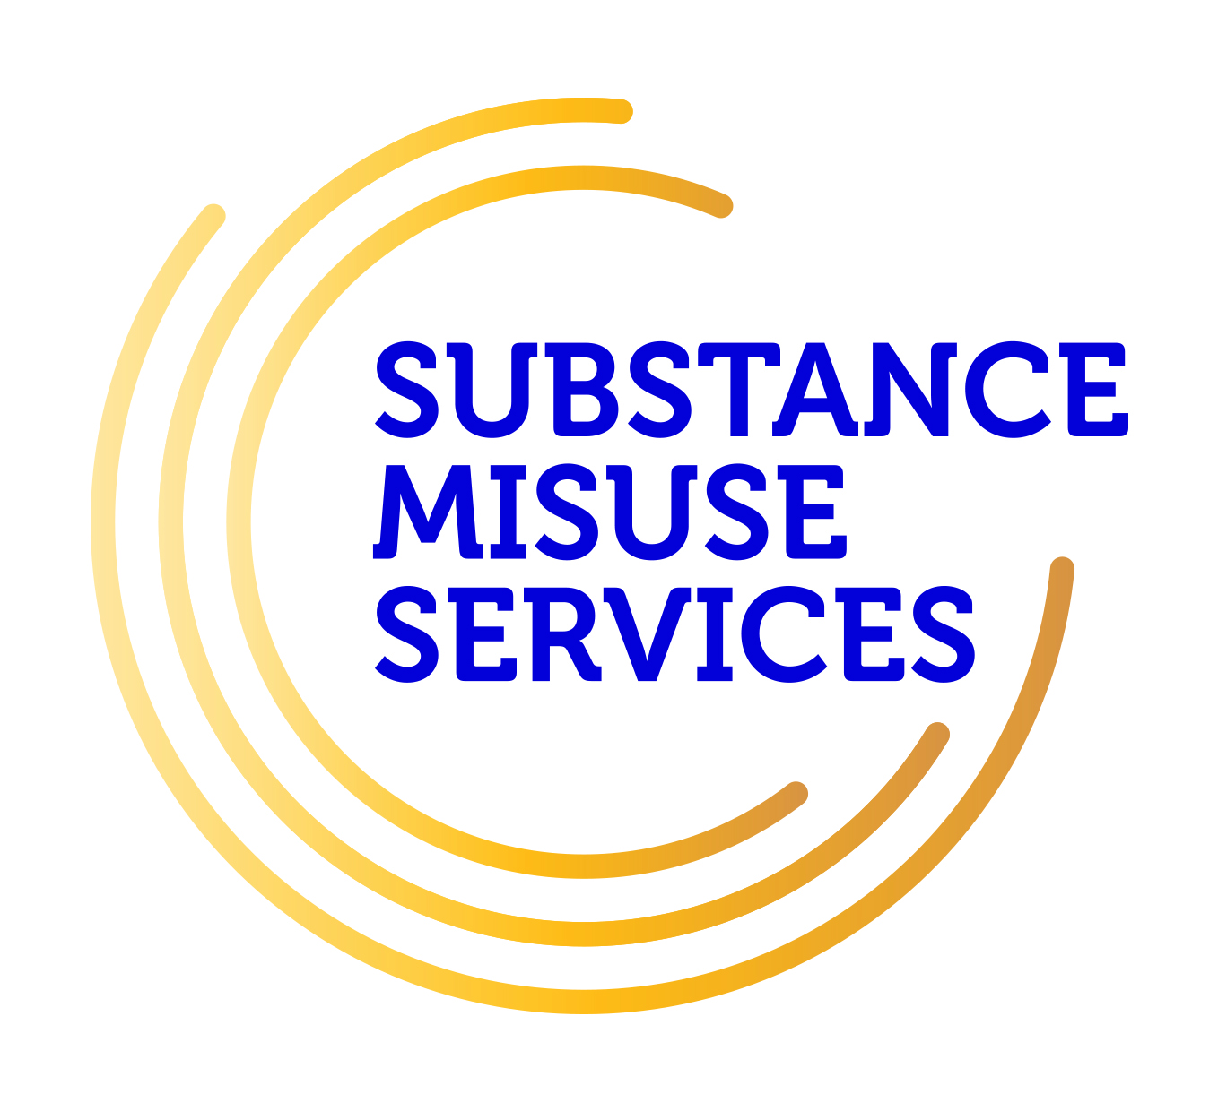
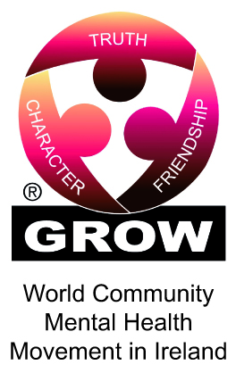
Student Signature _________________________________ Date _________________________
Recovery is moving on, achieving and learning, being the best and the best that I can be with confidence” Mental Health Discussion Group Clonmel 2013

