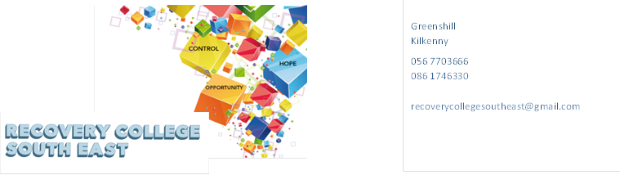
Website: www.recoverycollegesoutheast.com
Recovery College South East – Link Training Centre Enniscorthy
Recovery Education Programme April – June 2023

You are invited to join us in our new Recovery Education Programme for Spring/Summer 2023.

This year, we are delighted to be able to offer integrated/hybrid workshops which means you have the option of attending some of the workshops in person or join online from home as specified on the timetable. It is important if you choose the online option, that you indicate your preference on the enrolment form so the link can be sent to your email.

(For more detailed information on the workshops, please go to the Workshop Section of our Website – www.recoverycollegesoutheast.com.) You can scan our QR code for quick access to our website
- Complete the attached enrolment form and email it to the Recovery College South East at enrolrecoverycollegesoutheast@gmail.com or
- Phone us on 086 1746330 to enrol

VENUE | WORKSHOP NAME | DATES | TIME
April – June 2023
“Link”  Enniscorthy  VENUE WORKSHOP NAME DATES TIME  April – June 2023  “LINK”  Enniscorthy | Series of eight-week recovery education programme  Let’s Talk Recovery  Have you heard the term “Recovery” and wondered what it means? This workshop will introduce you to the concept of recovery as it applies to mental health and addiction challenges.  This workshop aims to increase your knowledge of recovery, explore common themes of recovery, and help you understand that recovery is possible. | Every Thursday  20th April | 9.30am-11am
 | CHIME for Recovery  CHIME stands for Connectedness, Hope, Identity, Meaning and Empowerment. These are the five common processes that people with mental health challenges consider essential for recovery to occur in their own lives.  The aim of this series of CHIME workshops is to:  Introduce CHIME as a framework for recovery  Explore practical ways of how to use each part of CHIME in our own lives to promote recovery  WORKSHOP NAME  April – June 2023  CHIME for Recovery (Connection)  Connecting with friends, family, peers and community is important for our wellbeing. This workshop explores the concept of connection and what it means for recovery. | 27th April  DATES  April – June 2023  27th April | 9.30am-11am  VENUE WORKSHOP NAME DATES TIME  April – June 2023  9.30am-11am
 | CHIME for Recovery (Hope)  We all need to have hope in our lives. Hope can help us on our recovery journey. This workshop explores the concept of hope and what we can do to build hope in our life. | 4th May | 9.30am-11am
 | CHIME for Recovery (Identity)  Finding out about ourselves and who we are is an interesting part of the recovery journey. This workshop explores the concept of identity and what it means for recovery | 11th May | 9.30am-11am
 | CHIME for Recovery (Meaning)  Exploring meaning and purpose in life has been shown to be an important part of recovery. This workshop discusses the concept of meaning and the role it plays in recovery | 18th May | 9.30am-11am
 | CHIME for Recovery (Empowerment)  Personal recovery helps us to make decisions, explore options and have a voice in our own wellbeing and in life in general. This workshop explores empowerment and what we can do for ourselves to feel empowered in our own life. | 25th May | 9.30am-11am
 | Understanding and managing depression taster  Depression can be experienced differently from person to person. This taster workshop helps you to explore depression and understand what it means to you and ways to help you manage it better. | 1st June | 9.30am-11am
 | Communication  The aim of this session is to explore the concept of communication and the role it plays in your life and to develop effective communication skills through exploring a range of tips and tools. | 8th June | 9.30am-11am
 | Review  Review of workshops and plan new workshops for the next eight weeks | 15th June | 9.30am-11am

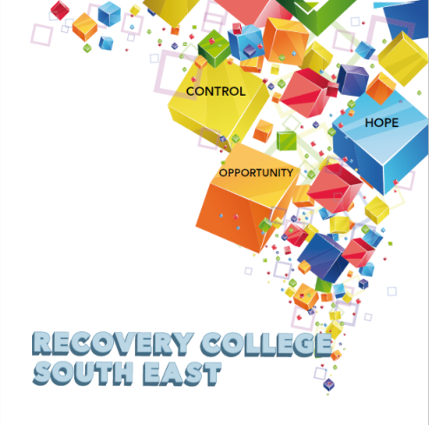

Greenshill
Kilkenny
056 7703666
086 1746330

recoverycollegesoutheast@gmail.com

Recovery College South East Enrolment Form
Course title | Commencement date

PLEASE COMPLETE USING BLOCK CAPITAL LETTERS
Surname:

First name(s)

Address:

Telephone: | Mobile | Home/Work
Contact Details in Case of Emergency: | Name | Number
Email:

All our workshops are based around discussion with some written exercises at your own discretion.

All our Workshops are free however, there is an enrolment fee of €5 per semester, per student. Our workshops are also open to everyone.

Are you happy for us to keep you informed by email, post or text about the Recovery College South East or future courses? ( Please tick this box if yes. )

Student Signature _________________________________ Date _________________________
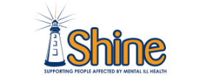
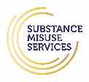
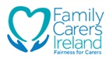
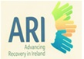
Recovery is moving on, achieving and learning, being the best and the best that I can be with confidence” Mental Health Discussion Group Clonmel 2013

