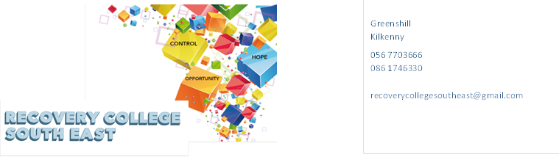
Website: www.recoverycollegesoutheast.com
Recovery College South East – Wexford: Enniscorthy
Recovery Education Programme: April – June 2024

You are invited to join us on our new Recovery Education Programme.

(For more detailed information on the workshops, please go to the Workshop Section of our Website – www.recoverycollegesoutheast.com.)

- Complete the attached enrolment form and email it to the Recovery College South East at enrolrecoverycollegesoutheast@gmail.com or
- Phone us on 086 1746330 to enrol

VENUE | WORKSHOP NAME | DATES | TIME
April – June 2024
“Link”  Enniscorthy  Y21 R2R1  “Link”  Enniscorthy  Y21 R2R1  “Link”  Enniscorthy  Y21 R2R1 | Series of eleven week recovery education programme  Personal Development (8 week programme)  The aim of this session is to explore the components of personal development and how it can benefit us in achieving our goals in life.  - Self-Awareness  The aim of this session is to develop the participants’ understanding of self-awareness and its benefits for everyday living.  - Developing Positive Thinking  The aim of this session is to help participants identify patterns of negative thinking and to acquire skills to help develop positive thinking.  - Building our Self Belief  Self-belief is a person’s belief in their ability to complete tasks and to achieve their goals (Bandura, 1995). This workshop will explore the term self-belief and how it can influence your life in many ways. It will also look at different ways of how to enhance your level of self-belief.  The aim of this workshop is to:  Discuss the term self-belief ad explore what it means to you  Gain an understanding of how self-belief can influence your sense of self and identity  Explore skills and strategies which help develop self-belief  - Assertiveness  The aim of this session is to enhance participants’ understanding of what assertiveness is and to practice assertiveness skills.  - Effective communication  The aim of this session is to explore the concept of communication and the role it plays in your life and to develop effective communication skills through exploring a range of tips and tools.  - Maintaining Motivation  The aim of this session is to help participants understand motivation and identify effective strategies to increase and maintain a high level of motivation.  - Self-care and Wellbeing  The aim of this session is to enable participants to understand what wellbeing is and to provide participants with practical self- care tips and tools to be able to manage and reduce stress in their day to day working and personal life.  To get the full benefit from this series of workshops, it is recommended that you attend all sessions. | Every Thursday  11th April  18th April  25th April  2nd May  9th May  16th May  23rd May  30th May | 9.30-11am
 | Understanding and Living with Hearing Voices  The experience of hearing voices can differ from person to person. The aim of this workshop is to gain a better understanding of the common nature of voice hearing, to explore and share ideas for managing and living well with hearing voices.  See workshop description – Page 5 | Thursday 6th June | 9.30-11am
 | Journalling for Wellbeing  If you have heard about journaling but never tried it or got a journal but never used it this is the perfect place to start. You will learn how journaling helps to boost your mental health, reduce depression and anxiety.  See workshop description – Page 5 | Thursday 13th June | 9.30 – 11am
“Link”  Enniscorthy  Y21 R2R1 | Self-discovery: Understanding Mindfulness – An Introduction  Mindfulness is the innate human ability of paying attention without judgement which, can be strengthened through practice and can benefit mental health.  The aim of this course is to:  - Gain a basic understanding of Mindfulness  - Explore your inner world with open curiosity and friendliness.  - Experience your senses of, sight, touch, smell, taste and hearing more fully  See workshop description – Page 6 | Thursday 20th June | 9.30 – 11am
VENUE | WORKSHOP NAME | DATES | TIME
April – June 2024
The Waterfront Pool & Leisure Centre, Enniscorthy  Y21 Y289 | Local Mental Health Forums  Mental Health Forums are for people who access services, family members and supporters, service providers and interested community members and groups. This is a partnership approach to mental health service improvement where we meet every 4-6 weeks to take feedback, progress plans, and decide together how to improve things for everyone.  For more information on how to get involved contact Paul Fallon at 086 7812951 or 056 7720591. | Tuesday 9th April | 11AM – 12.30PM
The Waterfront Pool & Leisure Centre, Enniscorthy  Y21 Y289 | Local Mental Health Forums  Mental Health Forums are for people who access services, family members and supporters, service providers and interested community members and groups. This is a partnership approach to mental health service improvement where we meet every 4-6 weeks to take feedback, progress plans, and decide together how to improve things for everyone.  For more information on how to get involved contact Paul Fallon at 086 7812951 or 056 7720591. | Tuesday 14th May | 11AM – 12.30PM
The Waterfront Pool & Leisure Centre, Enniscorthy  Y21 Y289 | Local Mental Health Forums  Mental Health Forums are for people who access services, family members and supporters, service providers and interested community members and groups. This is a partnership approach to mental health service improvement where we meet every 4-6 weeks to take feedback, progress plans, and decide together how to improve things for everyone.  For more information on how to get involved contact Paul Fallon at 086 7812951 or 056 7720591. | 11th June | 11AM – 12.30PM

Workshop Title | Description
Personal Development Programme (8 weeks)  To get the full benefit from this series of workshops, it is recommended that you attend all sessions. | - Introduction to Personal Development  The aim of this session is to explore the components of personal development and how it can benefit us in achieving our goals in life.  - Self-Awareness  The aim of this session is to develop the participants’ understanding of self-awareness and its benefits for everyday living.  - Developing Positive Thinking  The aim of this session is to help participants identify patterns of negative thinking and to acquire skills to help develop positive thinking.  - Building our Self Belief  Self-belief is a person’s belief in their ability to complete tasks and to achieve their goals (Bandura, 1995). This workshop will explore the term self-belief and how it can influence your life in many ways. It will also look at different ways of how to enhance your level of self-belief.  The aim of this workshop is to:  - Discuss the term self-belief ad explore what it means to you  - Gain an understanding of how self-belief can influence your sense of self and identity  - Explore skills and strategies which help develop self-belief  - Assertiveness  The aim of this session is to enhance participants’ understanding of what assertiveness is and to practice assertiveness skills.  - Effective communication  The aim of this session is to explore the concept of communication and the role it plays in your life and to develop effective communication skills through exploring a range of tips and tools.  - Maintaining Motivation  The aim of this session is to help participants understand motivation and identify effective strategies to increase and maintain a high level of motivation.  - Self-care and Wellbeing  The aim of this session is to enable participants to understand what wellbeing is and to provide participants with practical self- care tips and tools to be able to manage and reduce stress in their day to day working and personal life.
Understanding and Living with Hearing Voices | The experience of hearing voices can differ from person to person. Our uniqueness as individuals is often reflected in the voices people experience. These voices can have distinct content, identities, meaning and impact on the person experiencing them.  The aim of this workshop is:  - To gain a better understanding of the common nature of voice hearing,  - To explore the different individual experiences within the group  - To discuss and share ideas for managing and living well with hearing voices
Journaling for Wellbeing | If you have heard about journaling but never tried it or got a journal but never used it this is the perfect place to start. In this workshop, you will learn how journaling helps to boost your mental health, reduce depression and anxiety. You will learn easy ways to express yourself and gain a better understanding of yourself. Together we will explore different ways to journal and if you do not like writing, don’t worry! There are other ways to journal that might surprise you.  The aim of this workshop is to introduce you to the benefits of journaling for mental health and self-expression, providing a supportive environment to explore various journaling methods, including non-writing alternatives, for personal growth and wellbeing.
Self-discovery: Understanding Mindfulness – An Introduction | Mindfulness involves noticing what's happening in the present moment, without judgement. You might take notice and be aware of your mind, body or surroundings.  So, it involves training in techniques in paying attention to what's going on inside of you as well as training to cultivate an attitude of acceptance and kindness to your internal experience.  Mindfulness can help you:  - become more self-aware  - feel calmer and less stressed  - feel more able to choose how to respond to your thoughts and feelings  - cope with difficult or unhelpful thoughts  - be kinder towards yourself.

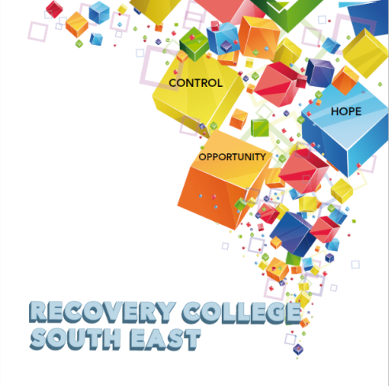

Greenshill
Kilkenny
056 7703666
086 1746330

recoverycollegesoutheast@gmail.com

Recovery College South East Enrolment Form
Course title | Commencement date

PLEASE COMPLETE USING BLOCK CAPITAL LETTERS
Surname:

First name(s)

Address:

Telephone: | Mobile | Home/Work
Contact Details in Case of Emergency: | Name | Number
Email:

All our workshops are based around discussion with some written exercises at your own discretion.

All our Workshops are free and our workshops are open to everyone.

Are you happy for us to keep you informed by email, post or text about the Recovery College South East or future courses? (Please tick this box if yes. )

Student Signature _________________________________ Date _________________________
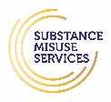
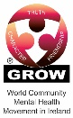
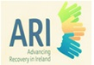
Recovery is moving on, achieving and learning, being the best and the best that I can be with confidence” Mental Health Discussion Group Clonmel 2013

