Mar
+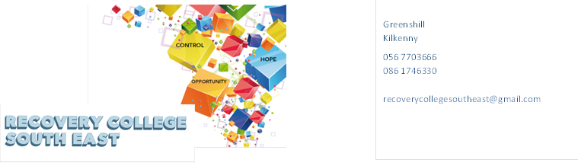
Website: www.recoverycollegesoutheast.com
Recovery College South East – Online Recovery Education Programme

You are invited to join us in our new Online Recovery Education Programme. It is free and will help us all feel connected and supported during these times of uncertainty.
Follow the simple steps below to connect to our online interactive workshops.
(For more detailed information on the workshops, please go to the Workshop Section of our Website – www.recoverycollegesoutheast.com )
- Complete the attached enrolment form and email it to the Recovery College South East at enrolrecoverycollegesoutheast@gmail.com or forward it to us by post.
Alternatively
- Phone us on 086 1746330 to enrol
- Download the free ZOOM app on your mobile phone or/and your laptop.
We are offering a series of ‘stand alone’ workshops that deal with specific issues related to maintaining good mental health. The 8 workshops are interrelated yet separate, and allow participants to attend one, more or all of them, depending on your choice and availability.
The workshops are aimed around how best to nourish and preserve our own emotional well-being, and nurture positive mental health. There will be learning opportunity in each workshop and some time for participant discussion
July 2021
Coping with Stress |  | Tuesday 13th July | 11am – 12pm
Thinking Errors and Mood |  | Tuesday 20th July | 11am – 12pm
Procrastination |  | Tuesday 27th July | 11am – 12pm
August 2021
Resilience |  | Tuesday 3rd August | 11am – 12pm
Compassionate Mind |  | Tuesday 10th August | 11am – 12pm
Dealing with “Worry” |  | Tuesday 17th August | 11am – 12pm
10 Keys to Happier Living |  | Tuesday 24th August | 11am – 12pm
Changing Habits |  | Tuesday 31st August | 11am – 12pm
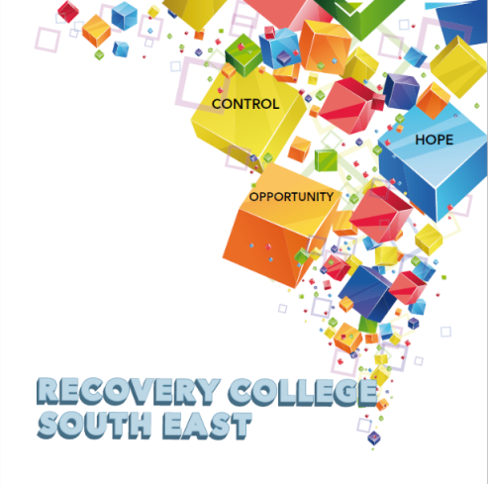

Greenshill
Kilkenny
056 7703666
086 1746330

recoverycollegesoutheast@gmail.com

Recovery College South East Enrolment Form
Course title | Commencement date

PLEASE COMPLETE USING BLOCK CAPITAL LETTERS
Surname:

First name(s)

Address:

Telephone: | Mobile | Home/Work
Contact Details in Case of Emergency: | Name | Number
Email:

All our workshops are based around discussion and group work. Pen and paper would be helpful to have to hand for participants.
Please note that we ask for your address and also an emergency contact number of a person who will come to your aid in times of an emergency during a virtual ZOOM workshop. For example, if a student collapses during a ZOOM workshop and is on their own in the house, we will be unable to support you without your address and contact number of a person who can call to your house. This has never happened but it is important that we are prepared if it does, and the facilitators can support you.

All our Workshops are free of charge.
Your contact details will be forwarded to the Recovery College South East. Are you happy for us to keep you informed by email, post or text about the Recovery College South East or future courses? (Please tick this box if yes.)

Student Signature _________________________________ Date _________________________
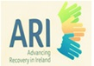
Recovery is moving on, achieving and learning, being the best and the best that I can be with confidence” Mental Health Discussion Group Clonmel 2013

Greenshill
Kilkenny
056 7703666
086 1746330

recoverycollegesoutheast@gmail.com

Workshop Descriptors
Workshop Title | Description
10 Keys to Happier Living | ” Happiness is not something ready-made, it comes from your own actions” (Dalai Lama)  We all want to lead a happy life; our actions and our choices can affect our happiness.  This 60-minute workshop will look at practical tips in which you can take control of your own wellbeing and happiness, by incorporating the ten keys to happier living into everyday life.
Changing Habits | Have you ever stopped to think about your habits or how they impact your daily life?  While some habits can be detrimental, such as wasting an hour on Twitter when you should be studying, others can be great to have around. Learning to brush your teeth when you were young helps you have good dental health when you are older. However, everyone has some habits they would like to change and by breaking down the cycle of a habit, you can identify what triggers the routine and begin to address what really needs to change.  This 60-minute workshop will help you better understand habit formation and provide you with some practical tips on how to create and maintain beneficial habits
Compassionate Mind | Compassion focused mindfulness practice specifically looks at cultivating and fostering a kinder, more soothing approach to deal with difficult emotions and self-criticism.  This 60 minute workshop will show you how to cultivate and grow self compassion in your everyday life, to counteract challenging emotions and thoughts.
Coping with Stress | Being under pressure is a normal part of life. It can help you act, feel more energized and get results. We all experience stress differently in different situations. Stress can affect you both emotionally and physically, and it can affect the way you behave. Being overwhelmed by stress can lead to changes in our behaviors, feelings and mood.  This 60-minute workshop will give you some practical tips for coping with and reducing stress in our day to day living.
Dealing with “Worry” | Worry is a normal emotion, everyone worries to some degree. There is no right or wrong amount of worry. However, worry becomes a problem when it gets in the way of you doing what you want to do, affecting your day to day life, takes over and becomes over whelming.  This 60-minute workshop will give you the practical tools to help you manage worries.
Procrastination | Procrastination is a trap that many of us fall into. Procrastination is the action of delaying or postponing an important task, usually by focusing on less urgent, more enjoyable, and easier activities instead. In fact, 95 percent of us procrastinate to some degree. While it may be comforting to know that you're not alone, it can be sobering to realise just how much it can hold you back.. As with most habits, it is possible to overcome procrastination.  This 60 minute workshop will show you how you can recognise and work out why you are procrastinating and practical ways in which to break the habit of procrastination
Resilience | Resilience gives people the strength to tackle problems head-on, overcome adversity, and move on with their lives. Resilience is something that you can build in yourself. Resilience involves the ability to recover and rebound from challenges and setbacks. Being resilient can be important for helping people deal with a variety of problems and bounce back from life’s setbacks and challenges. There are steps that you can take to become more resilient.  This 60-minute workshop will give you some practical tips on how we can become more resilience and cope better with life’s challenges.
Thinking Errors and Mood | We all have thinking errors, all or nothing thinking, over generalizing, filtering out the positive, are but a few examples. These thinking errors impact on our emotions, and can lead to a variety of problems, including communication issues, relationship difficulties, and making unhealthy decisions. The good news about thinking errors is that you have the power to correct them. The key to this is recognising a thinking error while it’s happening, and learning how to challenge and replace that thought with a more accurate and real perception of what’s really going on?  This 60-minute workshop will show you some practical ways in which to challenge and replace common thinking errors.

