Mar
+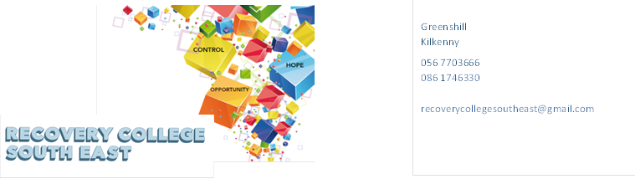
Website: www.recoverycollegesoutheast.com
Recovery College South East – Online Recovery Education Programme

You are invited to join us in our new Online Recovery Education Programme. It is free and will help us all feel connected and supported during these times of uncertainty.
Follow the simple steps below to connect to our online interactive workshops.
(For more detailed information on the workshops, please go to the Workshop Section of our Website – www.recoverycollegesoutheast.com )
- Complete the attached enrolment form and email it to the Recovery College South East at recoverycollegesoutheast@gmail.com or forward it to us by post.
Alternatively
- Phone us on 086 1746330 to enrol
- Download the free ZOOM app on your mobile phone or/and your laptop.
Date |  | Time | Workshop
Monday 21st September |  | 11am – 12.30pm | Understanding and Living with Anxiety (Week 1 of 4 Week Workshop)
 |  | 11am – 1.30pm | WRAP (Day 1 of 8 part workshop)
 |  | 2pm – 3.30pm | New - What is this thing called recovery?
 |  | 2pm – 3.30pm | Music for mood
Tuesday 22nd September |  | 11am – 12.30pm | New - Returning to work in the COVID 19 World
 |  | 11am – 1.30pm | WRAP (Day 2 of 8 part workshop)
 |  | 2pm – 3.30pm | Positive Thinking: Practicing Wellbeing
Wednesday 23rd September |  | 11am – 1.30pm | WRAP (Day 3 of 8 part workshop)
 |  | 11am – 12.30pm | New - Making changes: where to start and how to maintain
 |  | 2pm – 3.30pm | New - Let’s Talk Social Media and Wellbeing
 |  | 2pm – 3.30pm | Understanding and living with Addictions (Workshop 1 of 8)
Thursday 24th September |  | 11am – 12.30pm | Understanding Recovery for Families (Week 1 of 4 week workshop)
 |  | 11am – 12.30pm | Understanding Self Esteem (Workshop 1 of 2)
Friday 25th September |  | 11am – 12.30pm | Learning Self Compassion and Kindness for myself
Monday 28th September |  | 11am – 12.30pm | Understanding and Living with Anxiety (Week 2 of 4 Week Workshop)
 |  | 11am – 1.30pm | WRAP (Day 4 of 8 part workshop)
 |  | 2pm – 3.30pm | Good Stress/Bad Stress
Tuesday 29th September |  | 11am – 1pm | New - Mind over Mood Week 1 of 8 week workshop
 |  | 11am – 1.30pm | WRAP (Day 5 of 8 part workshop)
 |  | 2pm – 4pm | Working Together- Co-Production (Workshop 1 of 4)
 |  | 1pm – 5pm | Recovery Principles & Practice Part 1 (Closed)
Wednesday 30th September |  | 11am – 12.30pm | New - Staying well and Making plans - managing the ups and downs
 |  | 11am – 1.30pm | WRAP (Day 6 of 8 part workshop)
 |  | 2pm – 3.30pm | Understanding and Living with Addictions (Workshop 2 of 8)
Thursday 1st October |  | 11am – 12.30pm | Understanding Self Esteem (Workshop 2 of 2)
 |  | 11am – 12.30pm | Understanding Recovery for Families (Week 2 of 4 week workshop)
 |  | 2pm – 3.30pm | Introduction to Mindfulness
Friday 2nd October |  | 11am – 12.30pm | New - Making Connections :(Workshop 1of 3)  Building confidence in social situations
 |  | 11am – 12.30pm | Learning Kindness and compassion for myself
Monday 5th October |  | 11am – 12.30pm | Understanding and Living with Anxiety (Week 3 of 4 Week Workshop)
 |  | 11am – 1.30pm | WRAP (Day 7 of 8 part workshop)
 |  | 1pm – 5  pm | Recovery Principles and Practice Part 1 (Closed)
 |  | 2pm – 3.30pm | New -Talking and Listening: it works both ways (Workshop 1 of 3)  How do we communicate part 1
Tuesday 6th October |  | 11am – 1.30pm | WRAP (Day 8 of 8 part workshop)
 |  | 11am – 1pm | New - Mind over Mood Week 2 of 8 week workshop
 |  | 2pm – 4pm | Working Together- Co-Production (Workshop 2of 4)
Wednesday 7th October |  | 9.30am– 1.30pm | New - Practical Facilitation Skills (Workshop 1 of 4)
 |  | 2pm – 3.30pm | Understanding and Living with Addictions (Workshop 3 of 8)
Thursday 8th October |  | 11am – 12.30pm | Understanding Recovery for Families (Week 3 of 4 week workshop)
 |  | 11am – 12.30pm | Building my Self Confidence (Workshop 1 of 2)
 |  | 2pm – 3.30pm | Understanding and living with Voices
 |  | 2pm – 3.30pm | Good Stress Bad Stress
Friday 9th October |  | 11am – 12.30pm | New - Making Connections: (Part 2 of 3)  Meeting new people and building friendships
Monday 12th October |  | 11am – 12.30pm | Understanding and Living with Anxiety (Week 4 of 4 Week Workshop)
 |  | 11am – 1.30pm | WRAP (Day 1 of 8 part workshop)
 |  | 1pm – 5pm | Recovery Principles and Practice Part 1 (Closed)
 |  | 2pm – 3.30pm | New - Talking and listening : It works both ways Part 2 of 3; Communication and Our Emotions
 |  | 2pm – 3.30pm | Learning Self Compassion and Kindness for Myself
Tuesday 13th October |  | 11am – 1pm | New - Mind over Mood Week 3 of 8 week workshop
 |  | 11am – 1.30pm | WRAP (Day 2 of 8 part workshop)
 |  | 2pm – 4pm | Working together: Co-Production (Workshop 3 of 4)
Wednesday 14th October |  | 9.30am – 1.30pm | New - Practical Facilitation Skills (Workshop 2 of 4)
 |  | 11am – 1.30pm | WRAP (Day 3 of 8 part workshop)
 |  | 2pm – 3.30pm | Understanding and Living with Addictions (Workshop 4 of 8)
Thursday 15th October |  | 11am – 1pm | New - Take Charge of your Life Week 1 of 6 workshops
 |  | 11am – 12.30pm | Understanding Recovery for Families (Week 4 of 4 week workshop)
 |  | 2pm – 3.30pm | Building my Self Confidence (Workshop 2 of 2)
 |  | 2pm – 3.30pm | Understanding and living with Paranoia
Friday 16th October |  | 11am – 12.30pm | New - Making Connections ( workshop 3 of 3)  Making a weekend plan
Monday 19th October |  | 11am – 1.30pm | WRAP ( Day 4 of 8 part workshop)
 |  | 11am – 12.30pm | Loneliness and Isolation
 |  | 2pm – 3.30pm | New - Talking and Listening : It works both ways: (Part 3 of 3)  Learning Good Communication Skills
Tuesday 20th October |  | 11am – 1pm | New - Mind over Mood Week 4 of 8 week workshop
 |  | 11am – 1.30pm | WRAP ( Day 5 of 8 part workshop)
 |  | 2pm – 4pm | Working together : Co-Production (Workshop 4 of 4)
 |  | 7pm-8.30pm | Understanding Sleep: Getting a good night’s sleep
Wednesday 21st October |  | 9.30am – 1.30pm | New - Practical Facilitation Skills (Workshop 3 or 4)
 |  | 11am – 1.30pm | WRAP ( Day 6 of 8 part workshop)
 |  | 2pm – 3.30pm | Understanding and Living with Addictions (Workshop 5 of 8)
Thursday 22nd October |  | 11am – 1pm | New - Take Charge of your Life Week 2 of 6 workshops
 |  | 11am – 12.30pm | Assertiveness (Workshop 1 of 2)
 |  | 2pm – 3.30pm | Understanding Self Harm
 |  | 7pm – 9pm | Wellness Recovery Action Plan for Families (Week 1 of a 6 week workshop)
Monday 26th October |  |  | Bank Holiday and School Holidays
Tuesday 27th October |  | 11am – 1pm | New - Mind over Mood (Week 5 of 8 week workshop )
 |  | 11am – 1.30pm | WRAP (Day 7 of 8 part workshop)
Wednesday 28th October |  | 9.30am – 1.30pm | New - Practical Facilitation Skills (Workshop 4 or 4)
 |  | 11am – 1.30pm | WRAP ( Day 8 of 8 part workshop)
 |  | 2pm – 3.30pm | Understanding and living with Addiction (Workshop 6 of 8)
Thursday 29th October |  | 11am – 1pm | New - Take Charge of your Life Week 3 of 6 workshops
 |  | 11am – 12.30pm | Assertiveness (Workshop 2 of 2)
 |  | 7 pm – 9 pm | Wellness Recovery Action Plan for Families (Week 2 of a 6 week workshop
Friday 30th October |  | 11am – 12.30pm | Music For Mood

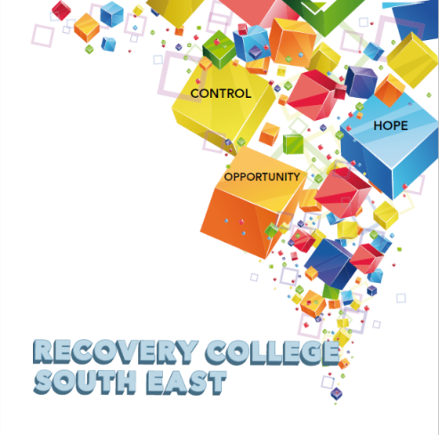

Greenshill
Kilkenny
056 7703666
086 1746330

recoverycollegesoutheast@gmail.com

Recovery College South East Enrolment Form
Course title | Commencement date

PLEASE COMPLETE USING BLOCK CAPITAL LETTERS
Surname:

First name(s)

Address:

Telephone: | Mobile | Home/Work
Contact Details in Case of Emergency: | Name | Number
Email:

All our workshops are based around discussion and group work. Pen and paper would be helpful to have to hand for participants.
Please note that we ask for your address and also an emergency contact number of a person who will come to your aid in times of an emergency during a virtual ZOOM workshop. For example, if a student collapses during a ZOOM workshop and is on their own in the house, we will be unable to support you without your address and contact number of a person who can call to your house. This has never happened but it is important that we are prepared if it does, and the facilitators can support you.

All our Workshops are free of charge.
Your contact details will be forwarded to the Recovery College South East. Are you happy for us to keep you informed by email, post or text about the Recovery College South East or future courses? (Please tick this box if yes.)

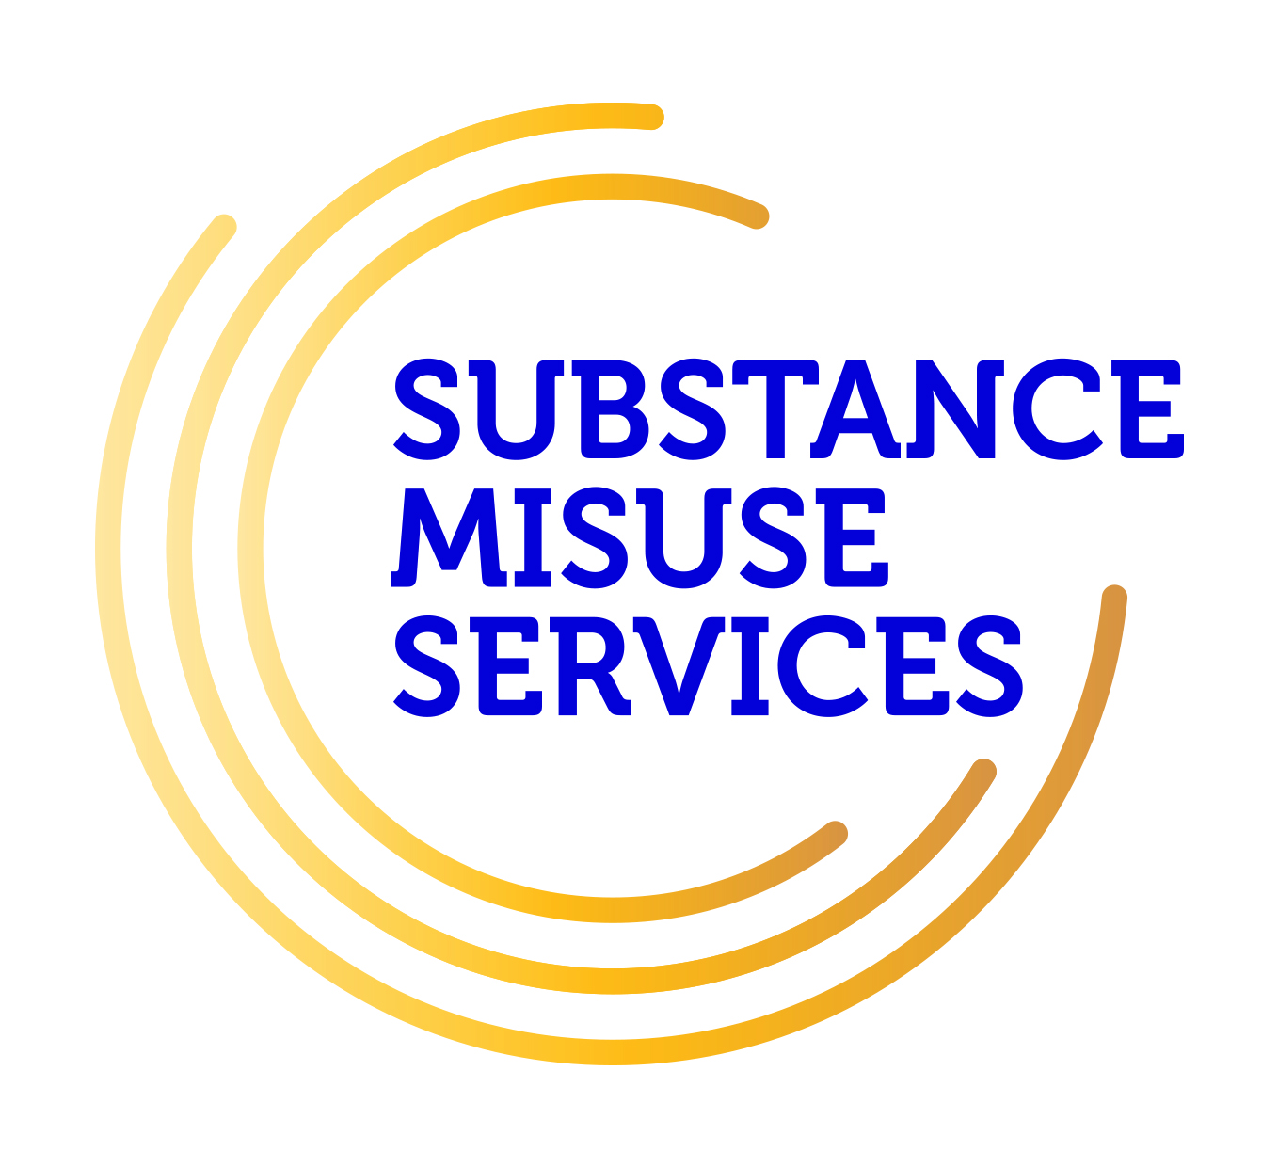
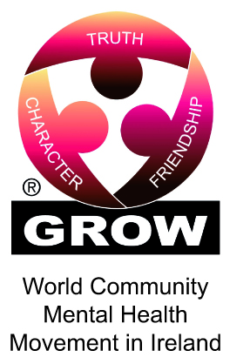
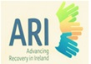
Student Signature _________________________________ Date _________________________
Recovery is moving on, achieving and learning, being the best and the best that I can be with confidence” Mental Health Discussion Group Clonmel 2013

Workshop Descriptors
Workshop Title | Description
Music for Mood  (Afternoon Workshop) | Do you listen to music? Has it ever uplifted your mood? How does music influence or affect our mental health?  The aim of this workshop is  - To explore how music can motivate and sooth us and how we can use music as a wellness tool in our everyday lives.  - To have fun
Understanding Self Esteem  (2 Morning Workshop) | Self-esteem is used to describe a person's overall sense of self-worth or personal value and it plays a significant role in your life. Healthy self-esteem helps you to navigate life with a positive and assertive attitude.  The aim of this 2 part workshop  - is to identity signs of healthy and low self-esteem  - to explore factors that influence self esteem  - to provide practical tips and tools which will enhance self-esteem
WRAP – Level 1  (8 part workshop) | WRAP is for everybody. WRAP helps you to get to know yourself. WRAP is your personal plan which you have put in place in the good times to remind you and guide you through the bad times. WRAP helps to achieve and maintain  wellness and gain more control over our lives and the way we feel. It is developed to help us identify what works and what doesn’t work and how we can get better at staying well.
Understanding and living with Anxiety ( Four week workshop ) | Everyone experiences periods of anxiety at some stage in their lives. We can feel tense, uncertain, fearful or nervous. Anxiety is a word used to describe these moments of discomfort. Anxiety can change from something everyone experiences in mild forms, to something which is persistent, excessive or over-whelming. It can begin to interfere with many aspects of your life – from confidence, to physical wellbeing and engagement in basic or complex activities of living.  The aim of this 4-part workshop is  - to explore the facts and origins of anxiety,  - explore the causes and symptoms associated with anxiety  - look at and how anxiety affects people in different ways –  - explore practical and effective ways of managing and living with anxiety.
Recovery Principles and Practice  (Afternoon Workshop) | Recovery Principles and Practice aims to bring an increased awareness to all staff in the Mental Health Services of the benefits of a recovery approach in practice. The training is built on incorporating the unique expertise that core stakeholders, service users, family members and service providers bring to the recovery process.
Understanding Sleep -Getting a Good Night’s Sleep  (Evening workshop) | Do you have difficulty getting off to sleep at night? Wake up early in the morning? Spend the night tossing and turning? Getting a good night’s sleep and developing a good sleep routine is important for your wellbeing and recovery.  This aim of this workshop is to  - Explore the different stages of sleep  - Discover the common causes of sleep problems  - Identify techniques to develop better sleeping habits.
Understanding and living with Voices | The experience of hearing voices can differ from person to person. Our uniqueness as individuals is often reflected in the voices people experience. These voices can have distinct content, identities, meaning and impact on the person experiencing them.  The aim of this workshop is  - to gain a better understanding of the common nature of voice hearing,  - to explore the different individual experiences within the group  - to discuss and share ideas for managing and living well with hearing voices
Learning Self Compassion and Kindness for Myself  (Morning workshop) | What does self - compassion mean to you? How can we show compassion and kindness to ourselves? The way you treat, think about and talk to yourself can have a ripple effect that impacts on your relationships and your choices.  The aim of this workshop is  - to explore the concept of self -compassion and help you cultivate more kindness towards yourself, through practical exercises for developing self-compassion  .
Good Stress/Bad Stress  (Morning workshop) | Many people believe that all stress is bad, but you may have heard that there's "good stress" and "bad stress." These days, many aspects of life can feel highly stressful, affecting our ability to think clearly, to relax or to look after ourselves. Whilst small amounts of stress can prompt us to action, too much stress over a long period of time can seriously affect our emotional and physical health.  The aim of this workshop is to  - help you to understand what stress is and how it can impact on your life positively and negatively.  - develop practical activities and suggestions that can help you to reduce the negative impact of increased stress in your life.
Understanding and living with Addictions | People often experience problems with both mental health and addictions, and finding the right help and support can be difficult.  The aim of this series of 8 part workshop is to  - Explore the many different aspects of this complex social issue.  - Examine the relationship between mental health challenges and addictions  - Identify commonly misused substances and the effects they can have on mental health, physical health and the person’s social circumstances  - Explore people’s reasons for the repeated misuse of substances  - Discuss the role of the family in the recovery process  - Support you in making informed choices on the recovery journey  - Identify the role of community supports in the recovery process
Building My Self Confidence  (2 Morning workshop) | Although self-confidence can mean different things to different people, in reality it simply means having belief in yourself.  Confidence is also a result of our life experiences and how we've learned to react to different situations.  The aim of this 2 part workshop is  - Explore and understand the role self-confidence can play in our lives,  - Develop a resourceful toolkit of practical skills, strategies and tips to increase self-confidence.
Loneliness and Isolation  (Morning workshop) | Everybody can be affected by loneliness and isolation, and research shows that it can especially cause difficulties for recovery in mental and physical health.  The aim of this workshop is to  - Explore how loneliness and isolation impacts on all aspects of life  - Share ideas on how loneliness and isolation can be positively addressed  - Identify practical ways of making connections to others.  - Explore what resources and services are available locally
Assertiveness Skills  (2 morning workshops) | Sometimes we find it hard to say what we really mean or find it difficult to say “no” to certain things. If we are struggling with mental health difficulties or other stresses it can be even harder. Assertiveness is a way of communicating that allows us to express our point of view and state our needs clearly. At the same time, assertive communication respects the needs of others.  The aim of this 2 part workshop is to  - Explore the rights and responsibilities of assertive behaviour  - Show how assertiveness can benefit you  - Explore strategies that enable people to build on and maintain their own assertiveness skills.
Understanding Recovery for Families | Family recovery is about all members of the family being able to live a life of their own choosing regardless of the challenges of mental health issues. Family recovery is about accepting that while we see things differently, there are key skills we can draw on to live a life of hope, empathy equality and autonomy. (Friends, family recovery booklet 2016)  The aim of this 4 week online workshop is:  - To explore the challenges, talk about the barriers and discuss pathways to wellness and empowerment to family recovery.  - To support you in navigating the mental health services and learn more about the support available for families, carers, supporters in recovery.  - To identify and share practical tips to enhance your own self care and build upon your knowledge and skills to support you and your family member.
What is this thing called Recovery? | Have you heard the term “Recovery” and wondered what it means? This workshop will introduce you to the concept of recovery as it applies to mental health and addiction challenges.  The aim of this workshop is to  - Increase your knowledge of what the term recovery means and its origins,  - Hear personal experiences of recovery,  - Explore the common themes in recovery and more,  - Understand that recovery is possible.
Returning to work in the COVID 19 World | Returning to work at this time for some will involve change and may lead to worry and potential stress, whether that means starting work again after a period of time, returning to the office or continuing to work from home.  The aim of this workshop is to  - Explore the transition back to work in the COVID 19 world.  - Provide practical and proactive steps people can take to minimise these fears and anxieties and make this process as smooth as possible.
Making changes: where to start and how to maintain | Although changes are a part of everyday life, for some these can cause disruption and distress.  The aim of this workshop is:  - To explore the process of life change and the impact it may have on one’s life.  - To develop healthy ways of managing the challenges that may arise after change.
Let’s Talk Social Media and Wellbeing | In today’s world of social distancing and social isolation, social media has been an invaluable tool for keeping connected to friends, family, work and the wider world. Whilst social media, has many benefits, it’s important to remember that spending too much time engaging with social media can also have its downside. Social media can never be a replacement for face to face human connection. It requires in person contact with others to trigger the hormones that alleviate stress and make you feel happier, healthier and more positive.  The aim of this workshop is to  - Explore how to take ownership of your social media use, and recognise what drives your social media use  - Identify the role social media plays in mental health, how it helps and how it hinders
Mind over Mood | Change how you feel by changing the way you think. This 8 week workshop is a Mindful Cognitive Behavioral Therapy (CBT) based programme to improve mood and is particularly suitable for those experiencing anxiety and depression.  The aim of this series of workshops is  - To improve your mood  - To learn skills and practical steps to feel better and make changes.  Each week builds on the previous week so it is advised to attend all of the weeks if possible. Home practice exercises will be suggested for between session practices.
Working Together- Co-Production | Co-Production has emerged and been identified as a concept that helps in the delivery of recovery orientated services within the mental health arena (BOBAIRD 2007; Dunston et al. 2009)  The process of co-production can occur in various different ways and many areas around the country have been successfully working in co-production.  This workshop is practical in nature and will involve group exercises that are designed to increase your skills and enhance your competence in all aspects of Co-Production.  The aim of this 4 part series of workshops is to  - Explore the co-production process and how it works within mental health services.  - Explore Co-Production and Recovery Education  - Understand and learn more about the role of Personal Narratives in Co-Production
Staying well and Making plans - managing the ups and downs | For many people it can feel as if their mental health difficulties are completely beyond their control. Support from others can be helpful but every person can become an expert in their own self-management.  Whatever challenges you face, recovery involves finding the personal resourcefulness and resilience to take back control over your life and what happens to you.  The aim of this workshop is to  - Support people to develop and use personal recovery plans that focus on what keeps you well,  - Manage the ups and downs in your life  - Develop coping skills for a crisis and knowing what gets you back on track.
Introduction to Mindfulness | Mindfulness is widely used these days in many different settings. Research has shown that Mindfulness is particularly useful in helping to manage issues such as stress, anxiety and other mental health challenges.  The aim of this taster workshop is:  - To introduce Mindfulness and explore what it is.  - To demonstrate short mindful practical meditations that can be used in ever day life for self-care and personal wellness.
- Making Connections – Building Confidence in Social Situations.  - Making Connections – Meeting new people and building friendships  - Making connections – Making a weekend Plan | Some times in your life you may lose touch with what you enjoy and what you are interested in. Overall, having a social network, hanging out with friends, catching up with family members or even chatting with a stranger can be incredibly beneficial to your health and overall wellbeing. Having a positive peer group provides individuals with a balanced perspective and is noted to have significant mental health benefits. In today’s world, It is easy to be isolated and disconnected for a number of reasons, busy lifestyle, mental health challenges, stigma, fear, anxiety, social phobia and more.  The aim of this 3 part workshop is to  - Explore the benefits of making connections for health and wellbeing,  - Discuss ways you may overcome any unhelpful thoughts and fears,  - Explore how it feels to make connections,  - Identify places and supporters to maintain connections.  - Create a personal plan to make connections
Talking and Listening: it works both ways  - How do we communicate  - Communications and our emotions  - Learning good communication skills | Good communication is key to any successful relationship, be it with your friends, family or in more formal or professional situations  The word conversation generally brings to mind talking. However, have you ever seen two people talking to each other at the same time, you will know that listening is just as important. In fact listening is half of a successful conversation. You take turns to talk and everybody feels heard.  The aim of this 3 part workshop is to  - Explore how we communicate  - Gain an understanding of the link between how you feel and how you communicate.  - Develop a range of communication skills that can help in areas such as relationships, work and social situations.
Practical Facilitation Skills | Delivering an effective presentation and having basic facilitation skills, whether for a recovery education workshop or for other training sessions, to talk at a conference or even get through a job interview, is becoming increasingly important.  The aim of this 4 part workshop is to  - Gain a good understanding of the roles and responsibilities of a facilitator  - Explore co-facilitation in relation to recovery education.  - Explore different facilitation styles, the power of body language, helpful attitudes, values and interpersonal skills.  - Gain practical experience in developing and delivering a short 10 minute presentation in a safe and supportive environment.
Understanding and living with Paranoia | Many people experience paranoid thoughts at some point in their lives and people have different experiences of paranoia. The symptoms vary in severity and may interfere with all areas of life.  The aim of this workshop is to  - Explore paranoia and gain a better understanding of what paranoia might mean for you, for someone you care about, or work with and how it may affect your life.  - Discuss some of the strategies for managing the experience of paranoia when it is distressing.
Taking Charge of your Life  (6 part workshop) | “Do you live your life by choice or chance”? Are you satisfied with the way your life is going?  This workshop supports people in creating rather than just observing their own life and seeks to inspire positive change.  The aim of this 6 part programme is to  - Support you to regain more control over your life and find greater personal freedom.  - Explore the model of “empowerment” where participants can learn together, to improve relationships and take charge of their actions.  - Develop practical skills in creating this change.
Understanding Self Harm | Life can at times be hard to cope with, especially if you have experienced traumatic events. Sometimes it feels that the only way to feel better or express how you feel is to hurt yourself in some way. What starts as a private act can become a habit which can get out of control. There are lots of myths about self-harm because it is something that many people find difficult to understand. This can make it a taboo, embarrassing subject that is uncomfortable to admit and address. The reality is that many more people self-harm than you think.  The aim of this workshop is to  - Improve your knowledge and understanding of self-harm, by clarifying what self-harm is and what leads people to self-harm  - Give you the confidence to think about and talk about this subject and to understand the very individual experience of it.
Positive Thinking – Practicing Wellbeing | The power of positive thinking is remarkable.  Developing a positive attitude can transform your whole life for the better.  The aim of this workshop is:  - To explore ways we practice positive thinking ourselves  - To provide practical tips and tools to maintain positive thinking patterns.

