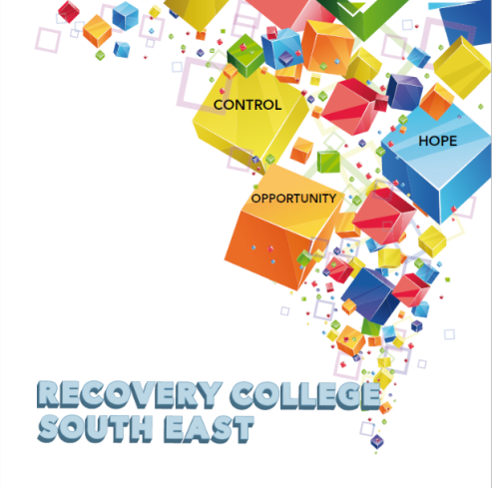

Greenshill
Kilkenny
056 7703666
086 1746330

recoverycollegesoutheast@gmail.com

Recovery College South East Enrolment Form
Course title | Commencement date

PLEASE COMPLETE USING BLOCK CAPITAL LETTERS
Surname:

First name(s)

Address:

Telephone: | Mobile | Home/Work
Contact Details in Case of Emergency: | Name | Number
Email:

All our workshops are based around discussion and group work. Pen and paper would be helpful to have to hand for participants.
Please note that we ask for your address and also an emergency contact number of a person who will come to your aid in times of an emergency during a virtual ZOOM workshop. For example, if a student collapses during a ZOOM workshop and is on their own in the house, we will be unable to support you without your address and contact number of a person who can call to your house. This has never happened but it is important that we are prepared if it does, and the facilitators can support you.

All our Workshops are free of charge.
Your contact details will be forwarded to the Recovery College South East. Are you happy for us to keep you informed by email, post or text about the Recovery College South East or future courses? (Please tick this box if yes.)

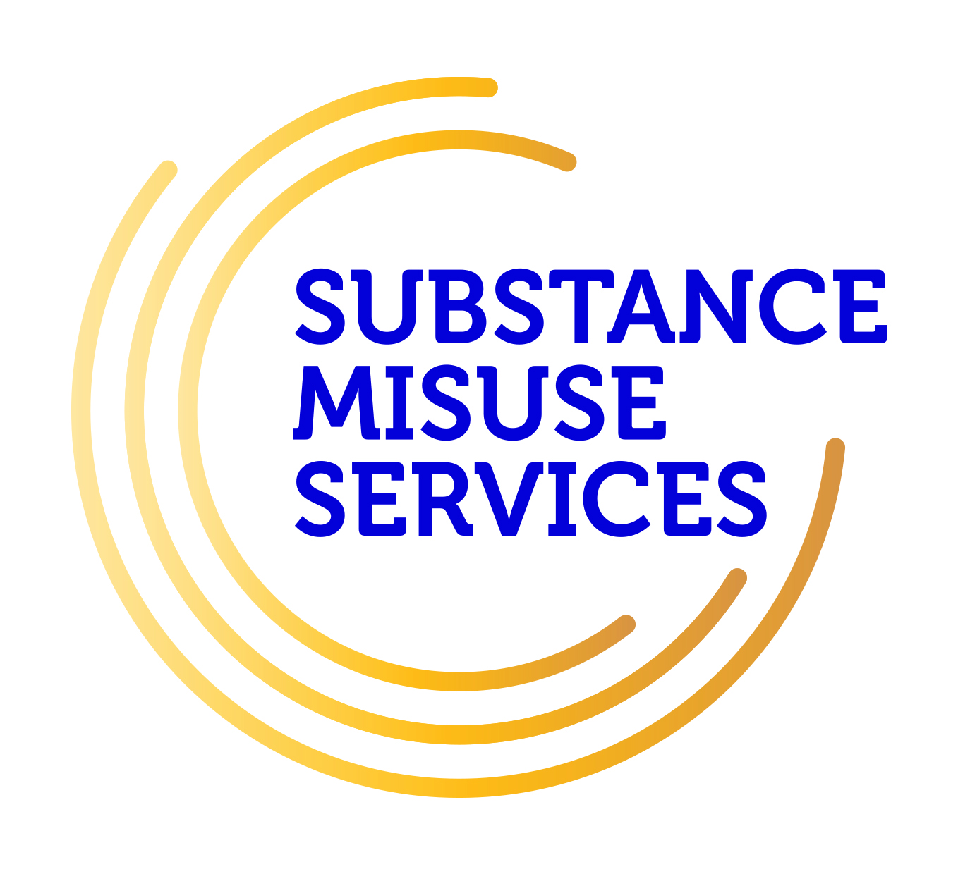
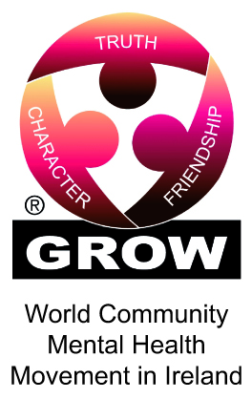
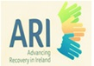
Student Signature _________________________________ Date _________________________
Recovery is moving on, achieving and learning, being the best and the best that I can be with confidence” Mental Health Discussion Group Clonmel 2013

