Mar
+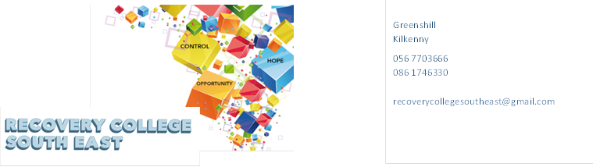
Website: www.recoverycollegesoutheast.com
Recovery College South East – Online Recovery Education Programme

You are invited to join us in our new Online Recovery Education Programme. It is free and will help us all feel connected and supported during these times of uncertainty.
Follow the simple steps below to connect to our online interactive workshops.
(For more detailed information on the workshops, please go to the Workshop Section of our Website – www.recoverycollegesoutheast.com )
- Complete the attached enrolment form and email it to the Recovery College South East at recoverycollegesoutheast@gmail.com or forward it to us by post.
Alternatively
- Phone us on 086 1746330 to enrol
- Download the free ZOOM app on your mobile phone or/and your laptop.

January 2021
Workshop |  | Date Time
Introduction to the Recovery College South East |  | Tuesday 12th January | 10am – 11am  2pm – 3pm  7.30pm – 8.30pm
Introduction to the Recovery College South East |  | Wednesday 13th January | 10am – 11am  2pm – 3pm  7.30pm – 8.30pm
Creative Writing |  | Wednesday 13th January and every Wednesday thereafter. | 3pm – 4pm
Introduction to the Recovery College South East |  | Thursday 14th January | 10am – 11am  2pm – 3pm  7.30pm – 8.30pm
Understanding and Managing Anxiety (4 week workshop) |  | Monday 18th, 25th January, Monday 1st and 8th February | 11am – 1pm
Managing Emotions (12 week workshop)  To get the full benefit from this series of workshops, it is recommended that you attend all sessions. |  | Tuesday 19th, 26th January,  Tuesday 2nd, 9th, 16th, 23rd February  Tuesday 2nd, 9th, 16th, 23rd and 30th March  Tuesday 13th April | 11am – 1pm
Understanding and Living with Addictions ( 6 week workshop)  To get the full benefit from this series of workshops, it is recommended that you attend all sessions. |  | Tuesday 19th, 26th January and Tuesday 2nd , 9th, 16th and 23rd February | 11am – 1.00pm
Music for Mood |  | Tuesday 19th January | 2pm – 4pm
Wellness Action Plan for Families |  | Wednesday 20th, 27th January and Wednesday 3rd and 10th February | 10am – 12pm
January 2021
Mindfulness (4 week workshop) |  | Wednesday 20th, 27th, January  Wednesday 3rd and 10th February | 11am – 12pm
Introduction to Recovery |  | Wednesday 20th January | 2pm – 4.00pm
Getting a good night’s Sleep (Evening Workshop) |  | Monday 25th January | 7pm – 9.00pm
Music for Wellbeing |  | Wednesday 27th January, 3rd, 10th and 17th February | 11am – 12.30 pm
Lunchtime Wellbeing |  | Wednesday 27th January | 1pm – 1.45pm
Discovering Hope |  | Wednesday 27th January | 2pm – 4pm
February 2021
WRAP (Wellness Recovery Action Plan) 5 week workshop  To get the full benefit from this series of workshops, it is recommended that you attend all sessions. |  | Monday 1st, 8th, 15th,22nd February and Monday 1st March | 1.30pm – 4.30pm
Introducing Co-Production (Afternoon workshop) |  | Tuesday 2nd February | 2pm – 4pm
Self-Awareness (Afternoon workshop) |  | Wednesday 3rd February | 2pm-4pm
Conversations about Suicidal Thoughts and Healing the Mind  To get the full benefit from this series of workshops, it is recommended that you attend all sessions. |  | Wednesday 3rd, 10th, 17th and 24th February | 11am – 1pm
Improve your Self Esteem (8 week workshop)  To get the full benefit from this series of workshops, it is recommended that you attend all sessions. |  | Thursday 4th, 11th, 25th February.  Thursday 4th, 11th, 25th March  Thursday 1st and 15th April | 11am – 1pm
Loneliness and Isolation (4 Week Morning Workshop) |  | Friday 5th , 12th, 19th and 26th February | 11am – 1.00pm
Good Stress/Bad Stress (Afternoon workshop) |  | Tuesday 9th February | 2pm – 4pm
Positive Self Talk (Afternoon workshop) |  | Wednesday 10th February | 2pm – 4pm
Family Recovery in Mental Health |  | Wednesday 17th and 24th February | 11am – 1pm
Compassionate Mind (4 week Morning workshop) |  | Wednesday 17th, 24th February and Wednesday 3rd, 10th March | 11am – 12pm
Taking Responsibility for my own wellness  (Afternoon workshop) |  | Wednesday 17th February | 2pm – 4pm
Lunchtime Wellbeing |  | Wednesday 24th February | 1pm – 1.45pm
Unwrapping our Mental Health Services (Afternoon workshop) |  | Wednesday 24th February | 2pm – 4pm
March 2021
Hearing Voices (Morning Workshop) |  | Monday 1st March | 11am – 1pm
Making the most of my appointments with Service providers (Afternoon workshop) |  | Wednesday 3rd March | 2pm – 4pm
Understanding Co-dependency within families |  | Wednesday 3rd March | 2pm – 4pm
Let’s Talk Social Media and Wellbeing |  | Friday 5th March | 11am – 1pm
Understanding and Living with Paranoia |  | Monday 8th March | 11am – 1pm
Assertiveness (2 week workshop) |  | Monday 8th and Monday 15th March | 2pm – 4pm
Communication Skills for Families |  | Wednesday 10th March | 2pm – 4pm
Understanding and Living with Psychosis |  | Monday 15th March | 11am – 1pm
Self-Belief (2 week workshop) |  | Monday 22nd and Monday 29th March | 2pm – 4pm
Good Stress/Bad Stress |  | Tuesday 23rd March | 2pm – 4pm
Lunchtime Wellbeing |  | Wednesday 24th March | 1pm – 1.45pm
Families: Forgiveness and Healing |  | Wednesday 31st March | 11am – 1pm
April 2021
Building my Self Confidence (2 week workshop) |  | Monday 12th and Monday 19th April | 2pm – 4pm
Co-Production : Working Together ( 2 week workshop) |  | Tuesday 13th, and 20th April | 1.30pm – 4.30pm
Understanding and Managing Anxiety (4 week Evening workshop)  To get the full benefit from this series of workshops, it is recommended that you attend all sessions. |  | Tuesday 13th, 20th, 27th April and  Tuesday 4th May | 7pm – 9pm
Understanding Medication |  | Wednesday 14th April | 11am – 1pm
Families and Recovery Models |  | Wednesday 14th April | 11am – 1pm
Understanding and Managing Depression (4 week workshop)  To get the full benefit from this series of workshops, it is recommended that you attend all sessions. |  | Friday 16th, 23rd, 30th April and Friday 7th May | 11am – 1pm
Personal Narrative (3 week workshop)  To get the full benefit from this series of workshops, it is recommended that you attend all sessions. |  | Tuesday 27th, April and Tuesday 4th and 11th May | 1.30pm – 4.30pm
April 2021
Mental Health and Family Caring Programme  (5 week programme) |  | Wednesday 28th April, Wednesday 5th, 12th, 19th and 26th May | 11am – 1pm
Lunchtime Wellbeing |  | Wednesday 28th April | 1pm – 1.45pm
May 2021
Understanding and Living with Bipolar (2 week workshop) |  | Wednesday 5th  Wednesday 12th May | 11am – 1pm
Understanding and Managing Stress (4 week workshop)  To get the full benefit from this series of workshops, it is recommended that you attend all sessions. |  | Monday 10th, 17th, 24th 31st May | 11am – 1pm
Talking and Listening - It works both ways (3 week workshop)  - How do we Communicate  - Communication and our Emotions  - Learning Good Communication Skills |  | Monday 10th , 17th and 24th May | 2pm – 4pm
Practical Facilitation Skills (4 week workshop) |  | Tuesday 18th, 25th May and Tuesday 1st and 8th June | 1.30 – 4.30pm
Understanding Loss and Bereavement (2 week workshop) |  | Wednesday 19th and 26th May | 11am – 1pm
Lunchtime Wellbeing |  | Wednesday 26th May | 1pm – 1.45pm
June 2021
Understanding and Managing Anger (2 week workshop) |  | Wednesday 2nd and 9th June | 11am – 1pm
Lunchtime Wellbeing |  | Wednesday 30th June | 1pm – 1.45pm

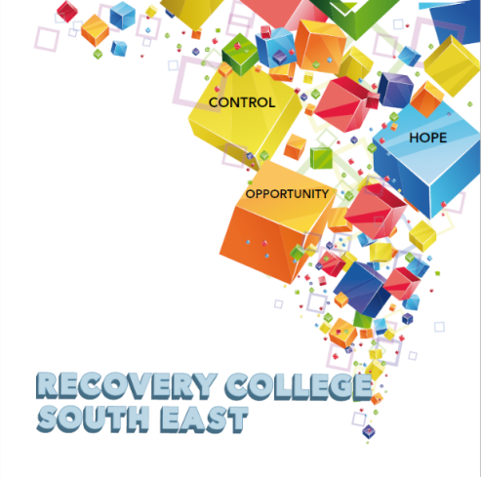

Greenshill
Kilkenny
056 7703666
086 1746330

recoverycollegesoutheast@gmail.com

Recovery College South East Enrolment Form
Course title | Commencement date

PLEASE COMPLETE USING BLOCK CAPITAL LETTERS
Surname:

First name(s)

Address:

Telephone: | Mobile | Home/Work
Contact Details in Case of Emergency: | Name | Number
Email:

All our workshops are based around discussion and group work. Pen and paper would be helpful to have to hand for participants.
Please note that we ask for your address and also an emergency contact number of a person who will come to your aid in times of an emergency during a virtual ZOOM workshop. For example, if a student collapses during a ZOOM workshop and is on their own in the house, we will be unable to support you without your address and contact number of a person who can call to your house. This has never happened but it is important that we are prepared if it does, and the facilitators can support you.

All our Workshops are free of charge.
Your contact details will be forwarded to the Recovery College South East. Are you happy for us to keep you informed by email, post or text about the Recovery College South East or future courses? (Please tick this box if yes.)

Student Signature _________________________________ Date _________________________
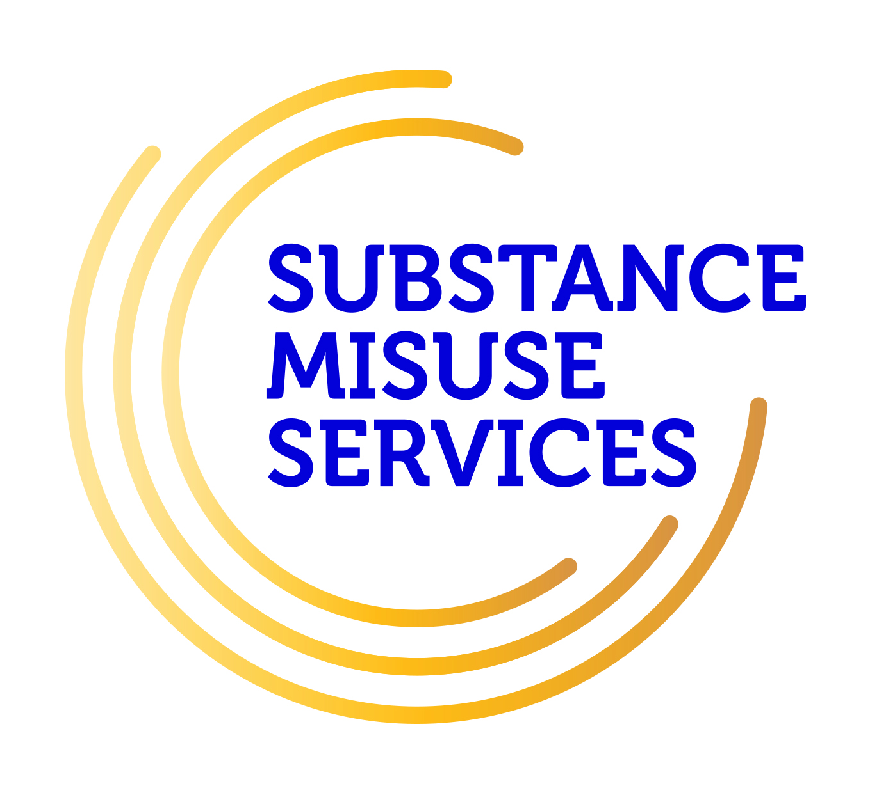
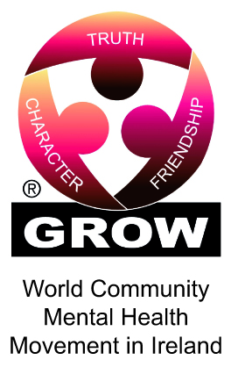
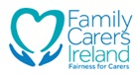
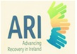
Recovery is moving on, achieving and learning, being the best and the best that I can be with confidence” Mental Health Discussion Group Clonmel 2013

Greenshill
Kilkenny
056 7703666
086 1746330

recoverycollegesoutheast@gmail.com

Workshop Descriptors
Workshop Title | Description
Assertiveness Skills  (2 morning workshops)  To get the full benefit from this series of workshops, it is recommended that you attend all sessions. | Sometimes we find it hard to say what we really mean or find it difficult to say “no” to certain things. If we are struggling with mental health difficulties or other stresses it can be even harder. Assertiveness is a way of communicating that allows us to express our point of view and state our needs clearly. At the same time, assertive communication respects the needs of others.  The aim of this 2 part workshop is:  - To explore the rights and responsibilities of assertive behaviour  - To show how assertiveness can benefit you  - To explore strategies that enable people to build on and maintain their own assertiveness skills.
Building My Self-Confidence  (2 Morning workshop)  To get the full benefit from this series of workshops, it is recommended that you attend all sessions. | Although self-confidence can mean different things to different people, in reality it simply means having belief in you.  Confidence is also a result of our life experiences and how we've learned to react to different situations.  The aim of this 2 part workshop is:  - To explore and understand the role self-confidence can play in our lives,  - To develop a resourceful toolkit of practical skills, strategies and tips to increase self-confidence.
Communication Skills for Families. | Family relationships can have ups and downs or go through times of difficulty.  Family boundaries define who is responsible for what, how parents and children interact, and how the family relates to the outside world. Communication within the family is extremely important because it enables members to express their needs, wants and concerns to each other.  The aim of this workshop is:  - To explore how to communicate effectively within your family  - To look at how you might set some healthy family boundaries for everyone
Compassionate Mind  (4 Week Workshop) | Compassion focused mindfulness practice specifically looks at cultivating and fostering a kinder, more soothing approach to deal with difficult emotions and self-criticism.  The aim of this workshop is:  - To recognise how critical self-talk lowers mood and sets up vicious negative cycles of feeling awful about ourselves.  - To build compassion for ourselves to help counteract these vicious cycles. With a compassionate focus we can learn to think in a way that helps us to be more accepting of ourselves
Creative Writing | Finding it hard to fill in your day? Looking for an activity or new interest? Why not join our online creative writing group? It’s fun, it’s entertaining and it is also a great way to meet new friends.  This group is open to anyone, regardless of whether you are an experienced writer, a beginner or even just curious abbot creative writing. This is a great way to express yourself and what may be going on for you in your world.  So, come along, join the group and give it a go. Looking forward to meeting you.
Discovering Hope | Hope is one of the key components of CHIME and to be hopeful can be a very helpful factor in overcoming life’s challenges and making the most of life. Having hope can also help us to support others when their hope may be low.  The aim of this workshop is :  - To discuss what hope is and why it is important in life  - To explore ways of how to cultivate hope
Families and Recovery Models | This workshop explores the dynamics of family recovery and the various models of recovery which can be of assistance to help families recover from mental health challenges.  The aim of this workshop is:  - To explore the concept of family recovery  - To discuss the challenges and factors that support family recovery  - To look at models of recovery and how they can promote family recovery
Family Recovery in Mental Health  To get the full benefit from this series of workshops, it is recommended that you attend all sessions. | Family recovery is about all members of the family being able to live a life of their own choosing regardless of the challenges of mental health issues. This workshop will explore: what is the meaning of family recovery in mental health" and what people can do to support themselves while supporting others and to get a greater understanding that recovery is possible for everyone.  The aim of this online workshop is:  - To explore the challenges, talk about the barriers and discuss pathways to wellness and empowerment to family recovery.  - To support you in navigating mental health services and learn more about the support that is available for families, carers and supporters in recovery.  - To identify and share practical tips to enhance your own self-care and build upon your knowledge and skills to support you and your family member.
Forgiveness and Healing for Families | For some, forgiveness and the healing that can come from it can be a crucial part of the recovery process. Forgiveness can be described as the letting go of recurrent anger, hostility or resentment resulting from interpersonal hurts and instead choosing to develop compassion and sympathy for those we perceive as causing the hurt. Forgiveness has been linked to reducing negative thoughts, emotions and behaviours and increasing healing and wellbeing in general (Akhtar et al., 2017).  The aim of this workshop is:  - To explore the concept of forgiveness and healing and what it means to you  - To discuss practical ways of how we can promote and develop forgiveness and healing to benefit our own lives
Good Stress/Bad Stress  (Morning workshop) | Many people believe that all stress is bad, but you may have heard that there's "good stress" and "bad stress." These days, many aspects of life can feel highly stressful, affecting our ability to think clearly, to relax or to look after ourselves. Whilst small amounts of stress can prompt us to action, too much stress over a long period of time can seriously affect our emotional and physical health.  The aim of this workshop is to:  - Help you to understand what stress is and how it can impact on your life positively and negatively.  - Develop practical activities and suggestions that can help you to reduce the negative impact of increased stress in your life.
Hearing Voices | The experience of hearing voices can differ from person to person. Our uniqueness as individuals is often reflected in the voices people experience. These voices can have distinct content, identities, meaning and impact on the person experiencing them.  The aim of this workshop is:  - to gain a better understanding of the common nature of voice hearing,  - to explore the different individual experiences within the group  - to discuss and share ideas for managing and living well with hearing voices
Improve your Self- Esteem  (8 Morning Workshop)  To get the full benefit from this series of workshops, it is recommended that you attend all sessions. | Everyone, at some point or another, is uncertain about themselves, lacks self-confidence, doubts their abilities, or thinks negatively of themselves. If you think that you have problems with low self-esteem, then this eight week programme might be helpful to you. It will look at what self-esteem is, and in particular low self-esteem, and what kind of impact low self-esteem might have on a person and their life. It teaches us how self-acceptance is the precondition of change and growth. A large portion of the course examines how low self-esteem develops, is maintained and how it can be improved through greater self-acceptance and a variety of strategies and skills. If applied these strategies and skills can help people gain confidence in changing self-defeating thoughts and behaviours and in overcoming the problems caused by low self-esteem.  At the end of each session, suggestions will be made for practice between sessions to maximize learning. Each week builds on the previous week so it is important to be able to attend for ALL of the eight weeks if at all possible in order for it to be of most benefit to you.
Introduction to Co-production | Co-production is one of the four principles which underpin the National Framework for Recovery in Mental Health. In many ways, it is a very simple concept which requires all people involved in mental health to work together to achieve more recovery orientated ways of managing and delivering mental health services.  This workshop will introduce you to co-production in terms of its historical context and development, what is involved in the process, its benefit to mental health services, and some of the challenges to working in this way.  This workshop is a good introduction to the topic and can be followed up with our more in-depth 2-week co-production series of workshops in April.  The aim of this workshop is:  - To introduce the concept of co-production  - To explore the main components of the co-production process in mental health services  - To discuss the benefits and challenges of co-production
Introduction to Recovery | Have you heard the term “Recovery” and wondered what it means? This workshop will introduce you to the concept of recovery as it applies to mental health and addiction challenges.  The aim of this workshop is to:  - Increase your knowledge of what the term recovery means and its origins,  - Hear personal experiences of recovery,  - Explore the common themes in recovery and more,  - Understand that recovery is possible.
Introduction to the Recovery College South East | Have you ever heard of recovery education or a recovery college?  The recovery college south east provides educational workshops for people who are experiencing mental health and addiction challenges. The workshops are all co-produced by people with lived experience of these challenges and who found recovery education beneficial to their recovery.  This introductory workshop will provide you with practical and helpful information around what a recovery college is and what it strives to achieve. It will explain the concept of recovery education and how this can greatly help people who experience mental health challenges, their loved ones or family members or those who may just have an interest in the area.
Let’s Talk Social Media and Wellbeing | In today’s world of social distancing and social isolation, social media has been an invaluable tool for keeping connected to friends, family, work and the wider world. Whilst social media, has many benefits, it’s important to remember that spending too much time engaging with social media can also have its downside. Social media can never be a replacement for face to face human connection. It requires in person contact with others to trigger the hormones that alleviate stress and make you feel happier, healthier and more positive.  The aim of this workshop is to:  - Explore how to take ownership of your social media use, and recognise what drives your social media use  - Identify the role social media plays in mental health, how it helps and how it hinders
Loneliness and Isolation  (4 morning workshops)  To get the full benefit from this series of workshops, it is recommended that you attend all sessions. | Everybody can be affected by loneliness and isolation, and research shows that it can especially cause difficulties for recovery in mental and physical health.  The aim of this workshop is to:  - Explore how loneliness and isolation impacts on all aspects of life  - Share ideas on how loneliness and isolation can be positively addressed  - Identify practical ways of making connections to others.  - Explore what resources and services are available locally
Lunchtime Wellbeing  (45 mins) | Do you make quality time for yourself in your day? Do you find it hard to take time out? This wellbeing session is a safe space for you to relax, unwind and refresh.  The session will include a variety of meditative practices such as mindfulness, visualization and self-compassion as well as some simple and easy to do Tai Chi and Yoga movements. No previous experience of these practices is necessary to join the session which will have a slow, lighthearted and easy pace. The session will end with an opportunity for questions or reflection within the group though this is optional to each individual.  The aim of this wellbeing session is:  - To create a relaxing space for you to take some time out for yourself  - To practice wellbeing techniques in a safe space
Making the most of my appointments with Service Providers | Appointments with any health service can be a challenging task for many people. This is no different for the mental health services and sometimes these challenges can have the effect that we do not always get the most from our appointments. For example, you may be afraid to ask any questions you have or voice your opinion if you are unsatisfied with the service. You may have had negative experiences in the past with service providers. This workshop will help you to develop better ways of making the most of your appointments with service providers.  The aim of this workshop is:  - To explore the various challenges we face as we attend appointments with service providers  - To discuss effective ways of ensuring that we get the most we can from our appointments
Managing Emotions (12 Week workshop)  To get the full benefit from this series of workshops, it is recommended that you attend all sessions. | Dialectical Behaviour Therapy (DBT) is extraordinarily effective in helping people manage overwhelming emotions. This type of Behaviour Therapy strengthens a person’s ability to handle distress without losing control or acting destructively through teaching a number of important skills. So, what are these skills and how will they help you? This course will teach 4 critically important skills that can both reduce the size of emotional waves, and help you keep your balance when these emotions overwhelm you. The 4 skills are;  - Distress Tolerance Skills will help you cope better with painful events by building up your resiliency and giving you new ways to soften the effects of upsetting circumstances.  - Mindfulness Skills will help you experience more fully the present moment while focusing less on painful experiences from the past or frightening possibilities in the future. Mindfulness will also give you tools to overcome habitual, negative judgements about yourself and others.  - Emotional Regulation Skills will help you to recognize more clearly what you feel and then to observe such emotions without getting overwhelmed by them. The goal is to modulate your feelings without behaving in reactive, destructive ways.  - Interpersonal Effectiveness Skills will give you tools to express your beliefs and needs, set limits, and negotiate solutions to problems - all the while protecting and treating others with respect.  At the end of the course by ‘putting it all together’ you will learn how to integrate all of these skills, in order to make them a regular part of your life. The hard part will be making the commitment to do the exercises and put your new skills into practice. Nothing will change by just listening and reading unless you implement - behaviorally - the new techniques and strategies that you will learn. That is why there will be in between session practice suggestions.
Mental Health & Family Caring Program  (5 Week Workshop) | This workshop will support you in building skills to look after your own wellbeing whilst caring for a person living with a mental health challenge.  The Aim of this workshop is :  - To reflect on and build tools and techniques to enhance self-care  - Expanded your understanding of the concepts of mental health, mental illness and recovery  - Increased awareness around boundaries with regard to personal wellbeing and the caring role  - To learn more about communication skills and active listening techniques  - Learn about what supports and services are available for families role
Mindfulness  (4 Week Workshop) | Mindfulness is about focusing on how things actually are in a given moment, not on what might have happened in the past, or how we might want things to be in the future.  With mindfulness we can learn to think in a way that helps us to be at peace with our thoughts and emotions.  The aim of this workshop is:  - To introduce Mindfulness and explore what it is.  - To demonstrate short mindful practical meditations that can be used in ever day life for self-care and personal wellness.
Music for Mood  (Afternoon Workshop) | Do you listen to music? Has it ever uplifted your mood? How does music influence or affect our mental health?  The aim of this workshop is:  - To explore how music can motivate and sooth us and how we can use music as a wellness tool in our everyday lives.  - To have fun
Music for Wellbeing | Music is one thing that is loved and celebrated across the world. We all have our favourite song and we can all be moved by music. Music can reflect how we feel and how we are in the world on any given day.  This 4-part series of workshops will explore music from the perspective of wellbeing. It will look at the positive effect music can have on us and how it can be a useful resource for overcoming mental health challenges.
Personal Narrative | Everyone one of us has a story to tell. Stories entertain us, inform us and can help us to make sense of our world and our life experience. The use and benefit of personal narrative in metal health recovery is well established and documented (Egglestone, 2019).  This 3-part workshop will introduce the topic of personal narrative and discuss some of the main aspects of its safe use in promoting and advancing recovery.  The aim of this workshop is:  - To explore the positive role of personal narrative in mental health recovery  - To look at some of the potential risks associated with personal narrative  - To discuss practical ways of developing and delivering personal narrative
Positive Self Talk | Self-talk is the internal conversation we all have with ourselves as we go about our daily lives. It may be informed by our inner beliefs, attitudes, life experiences and ideas. It can be both negative and positive and can have a significant effect on how we view and live life.  The aim of this workshop is:  - To explore positive self-talk and the benefit it can have in our lives  - To provide practical ways of developing positive self-talk in our life
Practical Facilitation Skills  To get the full benefit from this series of workshops, it is recommended that you attend all sessions. | Delivering an effective presentation and having basic facilitation skills, whether for a recovery education workshop or for other training sessions, to talk at a conference or even get through a job interview, is becoming increasingly important.  The aim of this 4 part workshop is:  - Gain a good understanding of the roles and responsibilities of a facilitator  - Explore co-facilitation in relation to recovery education.  - Explore different facilitation styles, the power of body language, helpful attitudes, values and interpersonal skills.  - Gain practical experience in developing and delivering a short 10 minute presentation in a safe and supportive environment.
Recovery Principles and Practice  (Afternoon Workshop) | Recovery Principles and Practice aims to bring an increased awareness to all staff in the Mental Health Services of the benefits of a recovery approach in practice. The training is built on incorporating the unique expertise that core stakeholders, service users, family members and service providers bring to the recovery process.
Self-Awareness | This workshop will explore how we can develop a greater awareness around who we are and how we can use this knowledge to improve how we relate to the world around us.  The aim of this workshop is:  - To explore the concept of self-awareness and how it can benefit our life  - To discuss practical techniques to help cultivate self-awareness
Self-Belief  (2 week workshop) | Self-belief is a person’s belief in their ability to complete tasks and to achieve their goals (Bandura, 1995). This 2-part workshop will explore the term self-belief and how it can influence your life in many ways. It will also look at different ways of how to enhance your level of self-belief.  The aim of this workshop is:  - To discuss the term self-belief and explore what it means to you  - Gain an understanding of how self-belief can influence your sense of self and identity  - Explore skills and strategies which help develop self-belief
Taking responsibility for my own wellness | Personal wellness can be influenced by many things such as societal and environment factors. This workshop will look at the role of personal responsibility in maintaining our wellness. It will explore how taking personal responsibility for our own wellness can be a positive step towards achieving personal freedom and empowerment within our life.  The aim of this workshop is:  - To define what personal responsibility means to you in the context of your wellness  - To explore the challenges and benefits to taking personal responsibility  - To provide practical ways of developing personal responsibility in your life
Talking and Listening: it works both ways  - How do we communicate  - Communications and our emotions  - Learning good communication skills | Good communication is key to any successful relationship, be it with your friends, family or in more formal or professional situations  The word conversation generally brings to mind talking. However, have you ever seen two people talking to each other at the same time, you will know that listening is just as important. In fact listening is half of a successful conversation. You take turns to talk and everybody feels heard.  The aim of this 3 part workshop is:  - To explore how we communicate  - To gain an understanding of the link between how you feel and how you communicate.  - To develop a range of communication skills that can help in areas such as relationships, work and social situations.
Understanding and  Managing Anger  (2 Week Workshop) | Anger is a normal and healthy emotion but for some it can be a difficult emotion to manage. This introductory workshop will help you to explore anger, its use and how it can have a negative effect on your life if unmanaged. The session will help you identify healthy ways of managing anger.  The aim of this workshop is:  - To explore what anger is and how it can affect us  - To explore strategies for managing safely and effectively
Understanding & Managing Co-dependency within Family Recovery | Co-dependency is a concept that initially emerged in the addictions field in the 1970s to address complex family relations that occurred as a result of substance dependencies (Calderwood, 2018). Co-dependency generally describes a one-sided relationship whereby one person almost entirely relies on the other for meeting their emotional and psychological needs.  This workshop looks at the concept of co-dependency and how it can develop within families. It also looks at some of the challenges it can cause for families and recovery as well as effective ways of managing co-dependency.  The aim of this workshop is to:  - Define and explore the concept of co-dependency  - Discuss the challenges to addressing co-dependency within families  - Provide practical ways of managing co-dependency
Understanding and living with Anxiety ( Four week workshop )  To get the full benefit from this series of workshops, it is recommended that you attend all sessions. | Everyone experiences periods of anxiety at some stage in their lives. We can feel tense, uncertain, fearful or nervous. Anxiety is a word used to describe these moments of discomfort. Anxiety can change from something everyone experiences in mild forms, to something which is persistent, excessive or over-whelming. It can begin to interfere with many aspects of your life – from confidence, to physical wellbeing and engagement in basic or complex activities of living.  The aim of this 4-part workshop is:  - to explore the facts and origins of anxiety,  - explore the causes and symptoms associated with anxiety  - look at and how anxiety affects people in different ways –  - Explore practical and effective ways of managing and living with anxiety.
Understanding and Living well with Bi Polar (2 week workshop) | Living with Bipolar can be a turbulent experience and for some can cause them to lose sight of who they are and what is important to them. This 2-part workshop will explore bipolar and help you to better understand what it is and how you can best live with it.  The aim of this workshop is:  - To explore what bipolar means to you and how it affects your life  - To discuss the causes of bipolar and the role of stress and underlying vulnerabilities  - To explore effective strategies to help manage and live well with bipolar
Understanding and living with Addictions  To get the full benefit from this series of workshops, it is recommended that you attend all sessions. | People often experience problems with both mental health and addictions, and finding the right help and support can be difficult.  The aim of this series of 6 part workshop is to:  - Explore the many different aspects of this complex social issue.  - Examine the relationship between mental health challenges and addictions  - Identify commonly misused substances and the effects they can have on mental health, physical health and the person’s social circumstances  - Explore people’s reasons for the repeated misuse of substances  - Discuss the role of the family in the recovery process  - Support you in making informed choices on the recovery journey  - Identify the role of community supports in the recovery process
Understanding and living with Paranoia | Many people experience paranoid thoughts at some point in their lives and people have different experiences of paranoia. The symptoms vary in severity and may interfere with all areas of life.  The aim of this workshop is to:  - Explore paranoia and gain a better understanding of what paranoia might mean for you, for someone you care about, or work with and how it may affect your life.  - Discuss some of the strategies for managing the experience of paranoia when it is distressing.
Understanding and Living with Psychosis | Psychosis can be experienced as having a different sense of reality to other people or hearing voices. While psychosis is surprisingly common, it can be a very unsettling and frightening experience for the person experiencing it as well as the people who care about them. This workshop is for anyone who wants to better understand psychosis and learn effective ways of living well it.  The aim of this workshop is:  - To help you to understand psychosis through exploring existing knowledge and different perspectives around the topic  - To provide coping strategies for living with psychosis and for promoting recovery
Understanding and Managing Depression (4 week workshop) | Depression can be experienced differently from person to person. This 4-part workshop helps you to explore depression and understand what it means to you and how you can manage it effectively.  The aim of this workshop is:  - To explore what depression is and the factors that may lead to depression  - To provide practical and effective ways to help promote recovery from depression
Understanding and Managing Stress (4 week workshop) | Stress is a common feature of modern living. Stress can be a mild experience for most people and normal levels of stress are seen as necessary for achieving goals or tasks in life. For others, stress can be severe and can have a negative impact on their life. This workshop will help you gain a better understanding of stress and will explore effective ways to help manage stress in your life.  The aim of this workshop is:  - To understand stress and the effect it can have on your wellbeing  - Discuss and explore practical ways of managing stress in your life
Conversations about Suicidal Thoughts and Healing the Mind | For many reasons, suicide can be a difficult topic to talk about. It can be described as a very personal phenomenon, there is the obvious loss associated with it, or there may be a lot of fear around raising the topic.  This 4-part series of workshops will start the conversation about suicide with the hope that it may help people better understand the issue.  The aim of this workshop is:  * Help you identify and manage unhelpful thinking patterns  * Support ourselves and others thinking about suicide  * Where to go and how to ask for help  * Cultivating practices that support the healing of the mind
Understanding Loss and Bereavement (2 week workshop) | We all experience loss and bereavement and it is probably one of the most difficult things we will encounter as we journey through life. There is no set way of managing bereavement and we all deal with loss in our own unique way.  This 2-part workshop will explore loss and bereavement and what it means to you.  The aim of this workshop is:  - To understand loss and bereavement and what it means to you  - To explore healthy ways of coping with loss and bereavement
Understanding Medication | In this workshop we will explore potential side effects of medication as well as other available options. We will also discuss access to reliable information re medication as well as who to contact if you have any questions in the future. This workshop will give you an opportunity to ask questions and learn from others.  The aim of this workshop is:  - To give you a chance to talk about the use of medications, the benefits, the challenges and how we can manage their use more effectively.
Getting a Good Night’s Sleep  (Evening workshop) | Do you have difficulty getting off to sleep at night? Wake up early in the morning? Spend the night tossing and turning? Getting a good night’s sleep and developing a good sleep routine is important for your wellbeing and recovery.  This aim of this workshop is to:  - Explore the different stages of sleep  - Discover the common causes of sleep problems  - Identify techniques to develop better sleeping habits.
Unwrapping our Mental Health Services | Our mental health service can play a central role in our wellbeing and recovery. For many, it can be a daunting task to try to understand how the service works. This workshop will help you to better understand the mental health service so that you can get the most benefit from it.  The aim of this workshop is:  - To provide an understanding of how the mental health service is delivered  - Discuss how to access help and support  - Explore available service supports
Wellness Action Plan for Families/Supporters | Wellness Action plan helps each member to contribute to plans that the family will use to improve day to day interactions, meet daily challenges and promote mutual co-operation in order to help make your family life what you want it to be.  The aim of this 4-week online workshop is:  - Looking at Wellness Tools  - To explore what would best support you and those around you during a crisis and a plan to move past this and to look after your wellness in your own way
Working Together- Co-Production  To get the full benefit from this series of workshops, it is recommended that you attend all sessions. | Co-Production has emerged and been identified as a concept that helps in the delivery of recovery orientated services within the mental health arena (BOBAIRD 2007; Dunston et al. 2009)  The process of co-production can occur in various different ways and many areas around the country have been successfully working in co-production.  This workshop is practical in nature and will involve group exercises that are designed to increase your skills and enhance your competence in all aspects of Co-Production.  The aim of this 2 part series of workshops is to:  - Explore the co-production process and how it works within mental health services.  - Explore Co-Production and Recovery Education  - Understand and learn more about the role of Personal Narratives in Co-Production.
WRAP – Level 1  (5 week workshop)  To get the full benefit from this series of workshops, it is recommended that you attend all sessions. | WRAP is for everybody. WRAP helps you to get to know yourself. WRAP is your personal plan which you have put in place in the good times to remind you and guide you through the bad times. WRAP helps to achieve and maintain  wellness and gain more control over our lives and the way we feel. It is developed to help us identify what works and what doesn’t work and how we can get better at staying well.

