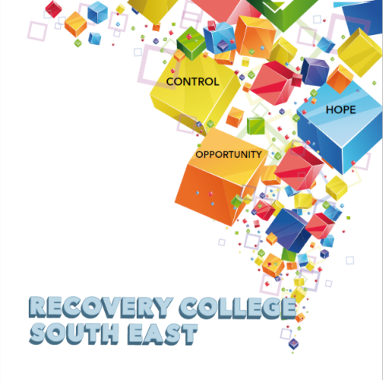

Greenshill
Kilkenny
056 7703666
086 1746330

recoverycollegesoutheast@gmail.com

Enrolment Form
Course title | Commencement date | In-house or Online (Zoom)  Please tick your preference below
 |  | In-house | Online (Zoom)
 |  | In-house | Online (Zoom)
 |  | In-house | Online (Zoom)

PLEASE COMPLETE USING BLOCK CAPITAL LETTERS
Surname:

First name(s)

Address:

Telephone: | Mobile | Home/Work
Email:
Contact Details in Case of Emergency: | Name | Number
Where did you hear about the Recovery College
Please tick the box that best describes you | Service User/Lived Experience_____________________________________  Family Member/Carer____________________________________________  Service Provider (Area of Work) __________________________________  _________________________________________________________________  Other (Please specify)/Prefer Not to Say____________________________________________  __________________________________________________________________
All our workshops are based around discussion and group work. Pen and paper would be helpful to have to hand for participants.
All our Workshops are free of charge.
Are you happy for us to contact you periodically by email, post or text about different events, workshops, surveys in relation to the Recovery College South East? (Please tick this box if yes.)

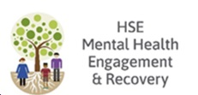
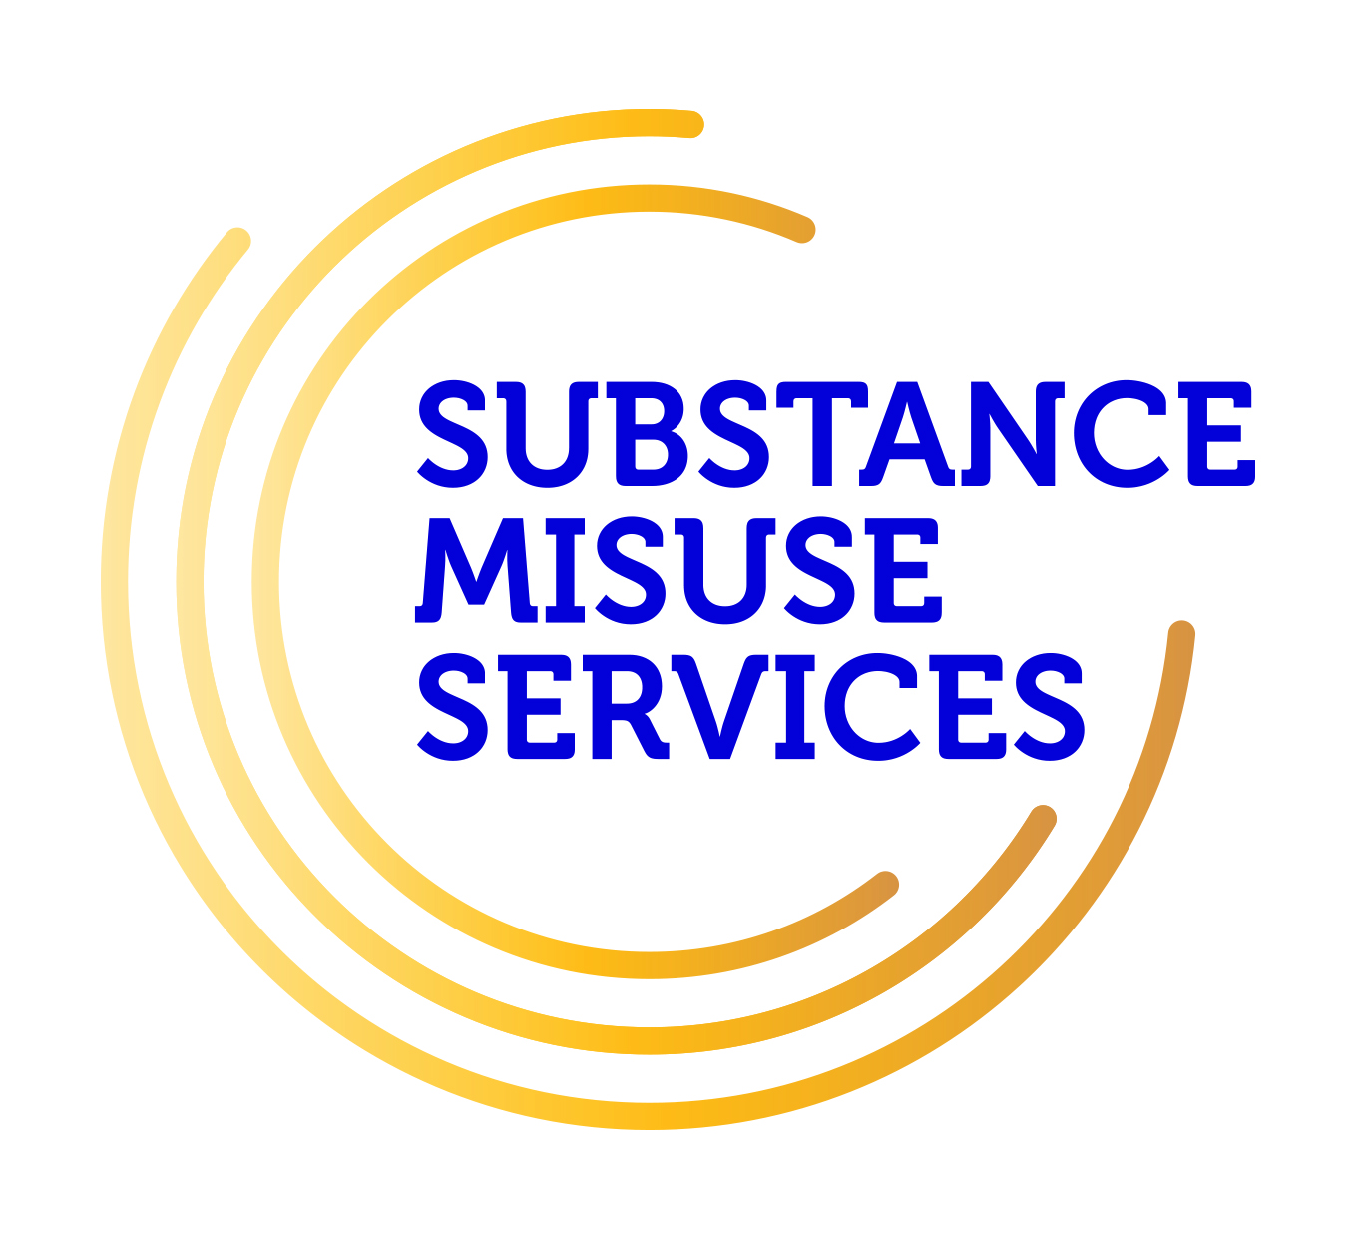
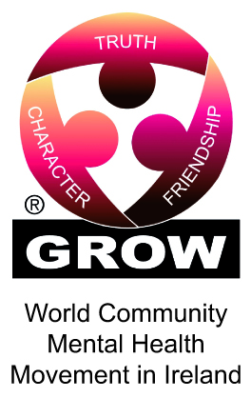
Student Signature _________________________________ Date _________________________
Recovery is moving on, achieving and learning, being the best and the best that I can be with confidence” Mental Health Discussion Group Clonmel 2013

