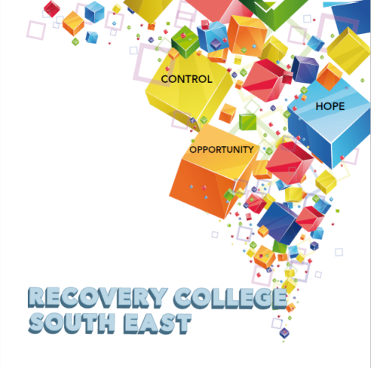

Greenshill
Kilkenny
056 7703666
086 1746330

recoverycollegesoutheast@gmail.com

College Enrolment Form
Course title | Commencement date

PLEASE COMPLETE USING BLOCK CAPITAL LETTERS
Surname:

First name(s)

Address:

Telephone: | Mobile | Home/Work
Email:

All our workshops are based around discussion with some written exercises at your own discretion.

All our Workshops are free however, there is an enrolment fee of €5 per semester, per student. Our workshops are also open to everyone.

Are you happy for us to keep you informed by email, post or text about the Recovery College South East or future courses? ( please tick this box. )

Student Signature _________________________________ Date _________________________

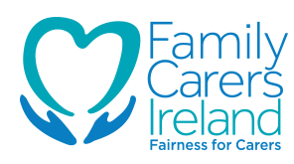
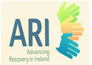
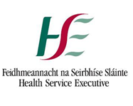
Recovery is moving on, achieving and learning, being the best and the best that I can be with confidence” Mental Health Discussion Group Clonmel 2013
